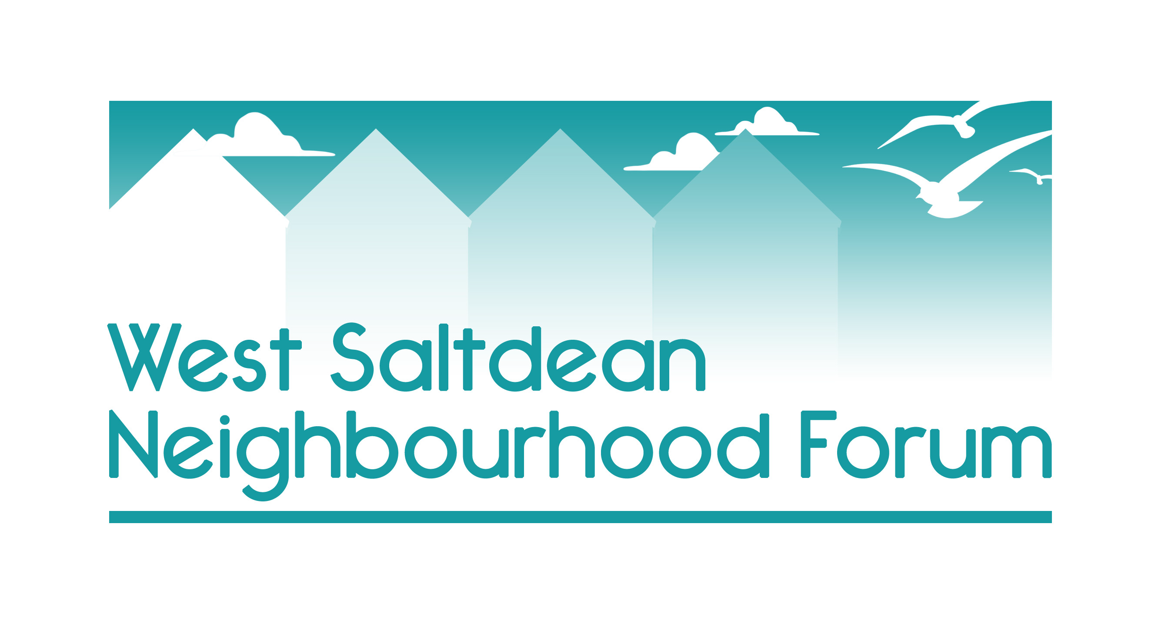
Appendix 8 - Shopping Centres and survey of residents’ shopping habits

Area 1 - Longridge Avenue

The largest retail area is on the west side of Longridge Avenue and realistically only the shops here are close enough to the seafront to attract tourists visiting the beach and the lido.

Longridge Avenue is currently home to mostly small independent enterprises including:

A pub 2 bars
A chemist 2 takeaways
Co-op Hardware shop
Charity shops Pet Shop
Hairdressers Newsagent
Estate Agent Funeral Parlour

These outlets are complemented by the outlets on the east side of Longridge Avenue which fall within East Saltdean.

Area 2: Lustrells Vale

Offerings are mostly small independent enterprises including:
Pharmacy Pizza restaurant/take away
Pizza takeaway Indian takeaway
Café Co-op
Newsagent Hairdresser

NB In July 2023 the butcher closed after 44 years citing rising costs and falling revenue as people continue to move to plant-based products and shopping in larger outlets.

There are three commercial offices on the parade which were formerly shops.

Area 3: Saltdean Vale

Newsagent Hairdresser
Commercial offices which were formerly shops

Evidence

2022 Survey of West Saltdean residents

How often do you use the shops & cafes in Lustrells Vale, Saltdean Vale and Longridge Avenue?

Daily 35.96%
Weekly 54.26%
Monthly 2.34%
Never 3.4%

The people who answered that they never used the local shops gave their reasons as:

prefer Brighton
cheaper elsewhere
They are too expensive
Use those in Rottingdean or Brighton
Lack of parking
Tatty areas

The most requested missing retail offerings in West Saltdean are:

- A bank
- Greengrocer
- Additional pubs
- Larger supermarket

###

