

Appendix 7: Facilities and services available at Saltdean seafront and on the undercliff

About Saltdean’s Beaches

Status

Saltdean seafront is part of both the ‘Beachy Head West’ designated Marine Conservation Zone (MCZ) and the Brighton to Newhaven Cliffs site of special scientific interest (SSI).

Saltdean beaches are an official Environment Agency (EA) bathing site which has been awarded 3 star Excellent bathing water quality based on samples taken between 2018 and 2022.

It has received a Seaside award by Keep Britain Tidy since 2016.

In May 2024 Saltdean beach was recognised as a blue flag beach.

The Landscape

Saltdean has five beach areas separated by concrete groynes. At the eastern end there is a rock boulder groyne. This marks the boundary into East Saltdean with the undercliff here maintained by Lewes District Councll.

The beaches and undercliff span a distance of 750 metres from the boundary of East Saltdean and to the western boundary in line with Cranleigh Avenue.

The beaches comprise steep shingle slopes at high tide and a combination of sand and rocks at low tide. The beaches are an ideal environment for shingle vegetation to thrive and there is natural planting (predominantly silver ragwort) on the northern edges or the beaches.

The height of the beaches has allowed means they are usable for sitting, walking, swimming and water sports at all tides.

Historical Background

In 1990 a vehicle access road was constructed (near the beach chalets) to provide access to Saltdean undercliff. This was jointly funded by Lewes District Council and Brighton Borough Council. It was built to provide access for the upcoming coastal protection works which began in 1990 at East Saltdean and then West Saltdean in 1995. Before the access road was built the nearest vehicle access point was Rottingdean.

In 1995 the undercliff between Saltdean and Rottingdean was reconstructed as part of the Brighton Coastal Protection Works. This involved the demolition of the existing groynes (these can still be seen at rock level), the construction of new concrete groynes at beach location, encasing the sea wall in concrete and installing a handrail along its distance. Access steps were provided every 200 metres along the undercliff and a vehicle ramp to the beach for maintenance, blocked off by wooden sleepers.

In 1996 the beaches between the groynes were topped with shingle to provide a safe bathing amenity beach and to protect the coast road.

Facilities
Both the beach and undercliff are managed by BHCC’s seafront team.

Saltdean’s official bathing season is May until September. During this period yellow buoys are positioned to create a swim zone.

The central and main beach directly opposite The White Cliffs café has lifeguards during the summer holidays.

The beaches to the east and west are open to dogs all year round. Dogs are not allowed on the central beaches from 1 May – 30 September.

Litter picking on the beach is conducted by BHCC as well as local volunteers organised by the Deans Clean-Up team.

On one of the beaches is a ramp for use by people on wheels installed in 2023 by BHCC. This site was chosen in consultation with the local Beach Access Team (formed by disability charity Scope), the Council's Coastal Engineer and the Seafront Team.

Another beach has a facility for kayaks and other small watercraft to be stored securely.

A webcam which shows the main beach and the sea was installed by residents can be found here: www.saltdeanssc.org/webcam

Public toilets were refurbished in early 2023 and include a cubicle for the less able.

The White Cliffs café lies to the north of the main beach and the undercliff at a mezzanine level. BHCC is the freeholder and the current occupants have a long repair and maintain lease.

About The Undercliff

Status
Saltdean Undercliff forms part of the England Coast Path (Living Coast) whose objective is to improve access to the coast

The Landscape
The undercliff was constructed in the early 1930s and opened at Saltdean in July 1935. It comprises a concrete walkway which provides a direct and flat route for walkers and cyclists travelling west.

To the north of the undercliff are chalk cliffs. To the south, a wall marking the boundary of the beach.

Saltdean tunnel was built in the 1930s and goes under the A259 creating a convenient pedestrian link between the seafront, Saltdean Lido and two car parks. Cycling is not permitted in the tunnel.

The tunnel was refurbished in 2020 by local residents and BHCC.

The undercliff is shared by walkers, bikes, e-bikes and e-scooters. Speeding is an ongoing issue creating tensions.

Facilities

To the west of the tunnel there is a rock bed bordered by concrete surrounds.

There are currently 20 concrete and 14 metal beach chalets which are owned by BHCC and leased on 5 year contracts to residents of Brighton & Hove City Council. One of these is leased to the Saltdean Community Association (a local charity) for use by Saltdean residents.

There are cycle lock-up bars and benches along the undercliff.

There are also various noticeboards including a community one.

There are currently 20 concrete beach chalets to the east which are owned by BHCC and leased on 5 year contracts

There are two showers and drinking water taps.

The Cliff Top

To the north of the undercliff above the chalk cliffs is a grassed wide verge with a mown path. It is characterised by natural planting and there are benches at various places

Access to the undercliff and beaches

The beach and undercliff are accessed in two ways: on foot through the tunnel under the A259 and from the A259 via a mezzanine level and a slope.

There is parking for three blue badge vehicles only at the mezzanine level. Other parking is at the two car parks owned by Saltdean Lido CIC to the north of the A259.

Brighton & Hove City Plan Part 2
BHCC City Plan Part 2 policy DM39 Development on the Seafront and the Coastal Strategy Studies and the Shoreline Management Plan cover the following so the West Saltdean plan defers to these WRT:
- coastal defences,
- development likely to have an effect on the Marine Conservation Zone

The City Plan specifies that :
- the importance of the seafront and beach as an open space must be safeguarded
- public access to and along the coast and to sea-based activities must be maintained and enhanced (see City Plan Part One policies CP16 Open Space and CP17 Sports Provision).
- proposals should protect and enhance the beach, shoreline and marine environment as open space and valuable natural habitats.

It writes that “it is important to recognise that coastal processes and climate change are likely to see narrowing of the beach in the medium to long term. For this reason, provision of public amenities should be small scale and of appropriate design, complementing other structures along the seafront and should not impede the maintenance of coastal defences including beach management”.

And that The Council will “support the provision of new small scale public amenities of an appropriate design (such as toilets and facilities for coastal sport uses such as showers, changing rooms and lifeguard facilities) on the shingle beaches or improvements to existing areas of hardstanding or access to the beach, shoreline and sea-based activities”.

Issues - Community feedback
In the survey of West Saltdean residents undertaken in Q4 2023, respondents were asked:

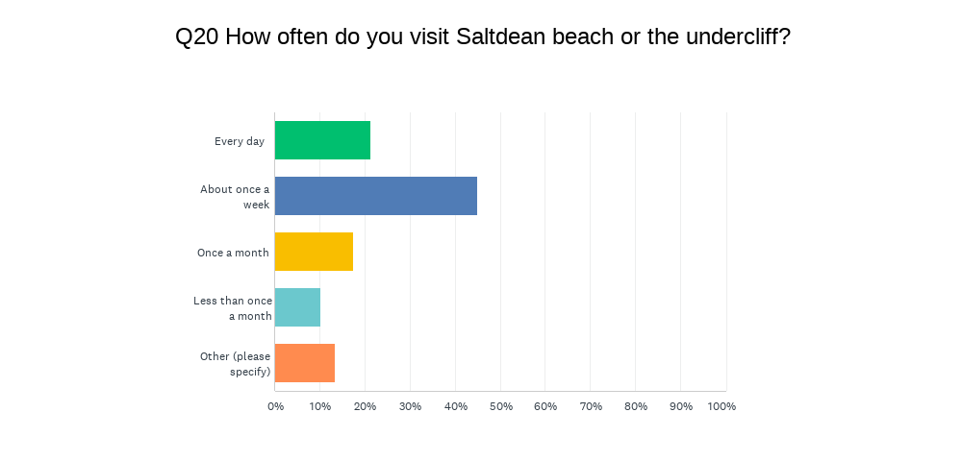

Residents were also asked what additional facilities they'd like to see along the undercliff with a wide variety of suggestions including:

- Better night-time lighting
- More seating and bins
- a designated cycle lane and better signage reminding riders to slow down
- more water sports faciliites
- an additional food and drink outlet
- more beach chalets
- a ramp for disabled people who want to use the beach
- storage for kayaks, canoes and paddleboards

##

