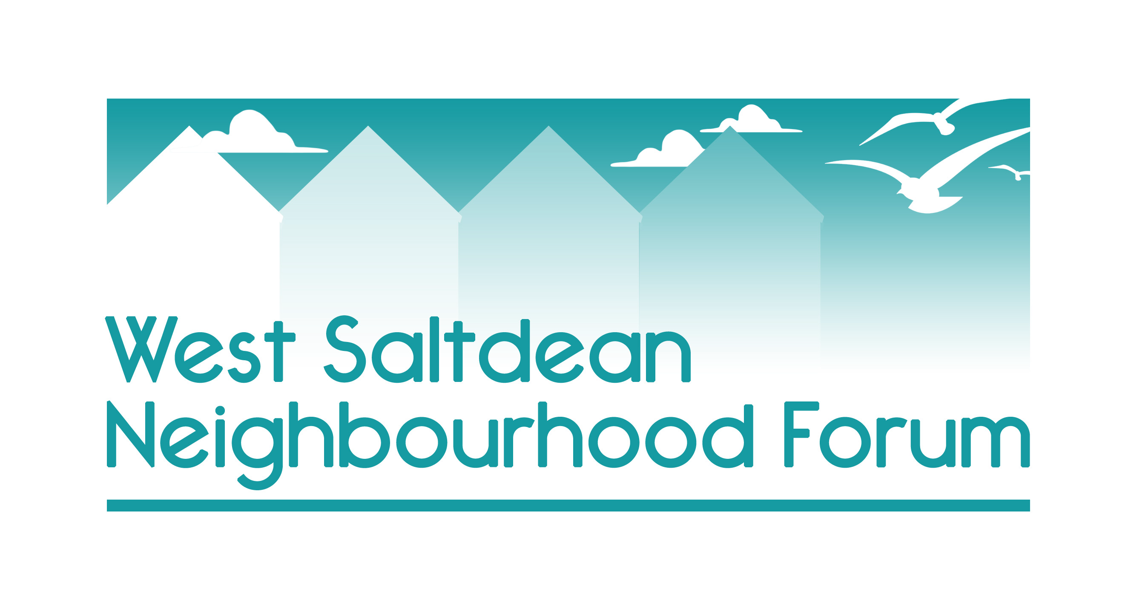

Appendix 6 - List of Community buildings and spaces

BHCC or Government-run buildings and services

Service | Operator | Comment
Saltdean Library – within the lido building | BHCC | Larger and refurbished library re-opened February 2024 with a mixture of staffed and self-entry opening every day.
Saltdean & Rottingdean medical practice | NHS | Within Grand Ocean development.
Saltdean Primary School | BHCC | School undersubscribed and will be moving to 2 form reception in the near future.  71 in Reception for 2023/4.  Takes students from outside West Saltdean
Saltdean Undercliff Toilets | BHCC | Complete refurbishment in 2023
Saltdean Oval Park including toilets | BHCC | Covered in open spaces section of plan

Current Community-Run Buildings and services

Building | Ownership  /Lease | Members only | Services | Spaces  for  community  hire | Future
Saltdean Lido | CIC | no | Pools x 2  Changing facilities  Restaurant  Café  Gym  Event space | yes | Secure
Saltdean Library | BHCC | yes | Library | no | Secure – within lido building
Building | Ownership  /Lease | Members only | Services | Spaces  for  community  hire | Future
St Martin’s Church Hall | Church | No | Room hire | Yes | Secure
St Nick’s Church Hall | Church | no | Room hire | Yes | secure
Community beach chalet x 1 | leased from BHCC to Saltdean Community Association | No |  | Yes | Lease until Nov 2026
Older Beach Chalets x 19 | Leased to BHCC residents by BHCC. Not exclusive to West Saltdean residents | Yes |  | Yes  1 x community beach chalet leased to Saltdean Community Association and available for day hire by Saltdean resdents. | Long waiting list
New beach chalets x 14 | Leased to BHCC residents by BHCC. Not exclusive to West Saltdean residents | yes | Water  Electricity |  | Long waiting list
Pavilion in the park | Informal agreement between BHCC & Bowls Club | Bowls & tennis |  | Yes | BHCC looking for clubs to take over maintenance responsibilities and this will happen in 2025.  Was protected by Oval Park’s ACV – now expired.
SUFC current clubhouse |  |  |  | yes | Future uncertain but too far back to be village hall
SUFC new club house | Will be finished in 2025. |  |  | Yes. | secure

Potential new community buildings

Saltdean tavern barn | Currently empty. Leased to brewery by BHCC. | Potential for indoor sports or use by the lido group

Local Sports Clubs operating with West Saltdean – volunteer-led

Saltdean Swim and Surf Club
SUFC
Bowls Club
Tennis Club

Local Leisure and Community Groups and Clubs – volunteer-led

Saltdean Community Association
Saltdean Residents’ Association
U3A
Townswomen Guild
Saltdean Arts Club
Saltdean Gardening Group

Private For-Profit Businesses providing services for the community

Boomerang Nursery | Building protected as within Saltdean Oval Park which is registered as an Asset of Community Value
Gingerbread nursery | Housed in a terrapin building that was originally a youth club. Planning permission for new building given in 2019 but BHCC as landlords refused as Oval Park has a covenant on it which forbids commercial buildings within it.
St Nicholas’ pre-school | Located in St Nicholas’ Church Hall
Saltdean Dental | Private business (sited in East Saltdean on West Saltdean border)

Private For-Profit organisations operational in West Saltdean

Various classes eg fitness | Classes in the park, on the undercliff and at St Nicholas, St Martin’s Church Halls and the lido

