LOCAL GREEN SPACE ASSESSMENT TOOL

There are no designated Local Green Spaces (LGS) in West Saltdean or elsewhere in the city in BHCC’s City Plan Part 2 policy DM38.

Local Green Space (LGS) designation gives a higher level of protection than standard open space policy, equivalent to that applied to Green Belts.

However LGS must be justified against specific criteria set out in the NPPF (paragraph 102) National Planning Policy Framework (publishing.service.gov.uk)

NPPF Paragraph 102 states that Local Green Space designation should only be used where the green space is:
- in reasonably close proximity to the community it serves;
- demonstrably special to a local community and holds a particular local significance, for example because of its beauty, historic significance, recreational value (including as a playing field), tranquillity or richness of its wildlife; and
- local in character and is not an extensive tract of land.
Further detail is also provided in National Planning Policy Guidance Open space, sports and recreation facilities, public rights of way and local green space - GOV.UK (www.gov.uk)

However, BHCC recognises numerous areas of designated open space within West Saltdean:

- Natural/Semi-Natural open space at the north end of Saltdean Vale (also a Local Wildlife Site)
- Land to the south of Westfield Rise and Coombe Meadow (also a Local Wildlife Site)
- Land to the east of Greenbank Avenue (also a Local Wildlife Site)
- All of Saltdean Park
- Areas of natural/semi-natural open space on the cliff tops
- Various pockets of amenity greenspace

In December 2023 the following green spaces which are all owned by Brighton & Hove City Council were assessed against the NPPF criteria and are proposed for designation in this plan:

SITE 1 – SUFC and North Saltdean Recreation Ground 2
SITE 2 – Looes Barn Close. Land behind. 6
SITE 3 – Westfield Avenue North and South 7
SITE 4 – Coombe Farm new housing estate 10
SITE 5 – Hailsham Avenue 12
SITE 6 – Stanmer Avenue 14
SITE 7 – Hempstead Road 16
SITE 8 - Mount Estate Plot 1 18
SITE 9 - Mount Estate Plot 2 20
SITE 10 - Mount Estate Plot 3 21
SITE 11 - Saltdean Primary School 24
SITE 12 – St Nicholas Church 25
SITE 13 – Saltdean Vale 27
SITE 14 - Saltdean Oval Park 29
SITE 15 – Saltdean Lido 32
SITE 16 – The Cliff Top 34
SITE 17 – Land south of Westfield Avenue North and east of Westfield Rise. Added to plan on 16 May 2024 following identification of site during Reg 14 consulation day on 12 May. 36

SITE 1 – SUFC and North Saltdean Recreation Ground

Site Name and Address (location) | Grid Ref
SUFC and North Saltdean Recreation Area | 50°48’52”N  0°2’5”W
Site owner | BHCC  SUFC area leased to club
Have they been informed / discussed? | Yes
Description and purpose / current use: | Football pitches  Open Space
Statutory designations (eg SSSI) | None
Other designations (eg LNR) | Includes a Local Wildlife Site  Sports pitches are protected in the NPPF paragraph 99.
Site allocations in Local Plan | No
Planning permission | No
Access & proximity including how close to the community it serves (in meters) | 50 metres from nearest homes
List any public rights of way to or across the site: | Full
Which of the following criteria does it meet? | Fully / Partially / Not (if F or P provide details)
- Beauty | P
- Historic significance / heritage | N
- Recreational value | F
- Tranquility | P
- Wildlife | F
Local in character – how would you describe for this statement?
3.5 Acres designated as public space to compensate for the loss of fields where Westbrook and Mayfield flats were built on Lustrells Vale.

Bridlepath and rights of way go straight out to the South Downs National Park.

Home of Saltdean United Football Club
Club houses: new clubhouse will open in 2024.
No plans for existing clubhouse.

3G pitch (coming soon) to replace current grass pitch. Both fenced off.

Parallel to the 3G pitch is a mown public open space which is surrounded on three sides by hedges. It has one drawn-out football pitch with two goal frames and another open area which is used for walking and picnicking.

Area (in hectares) | 1.3
Photograph
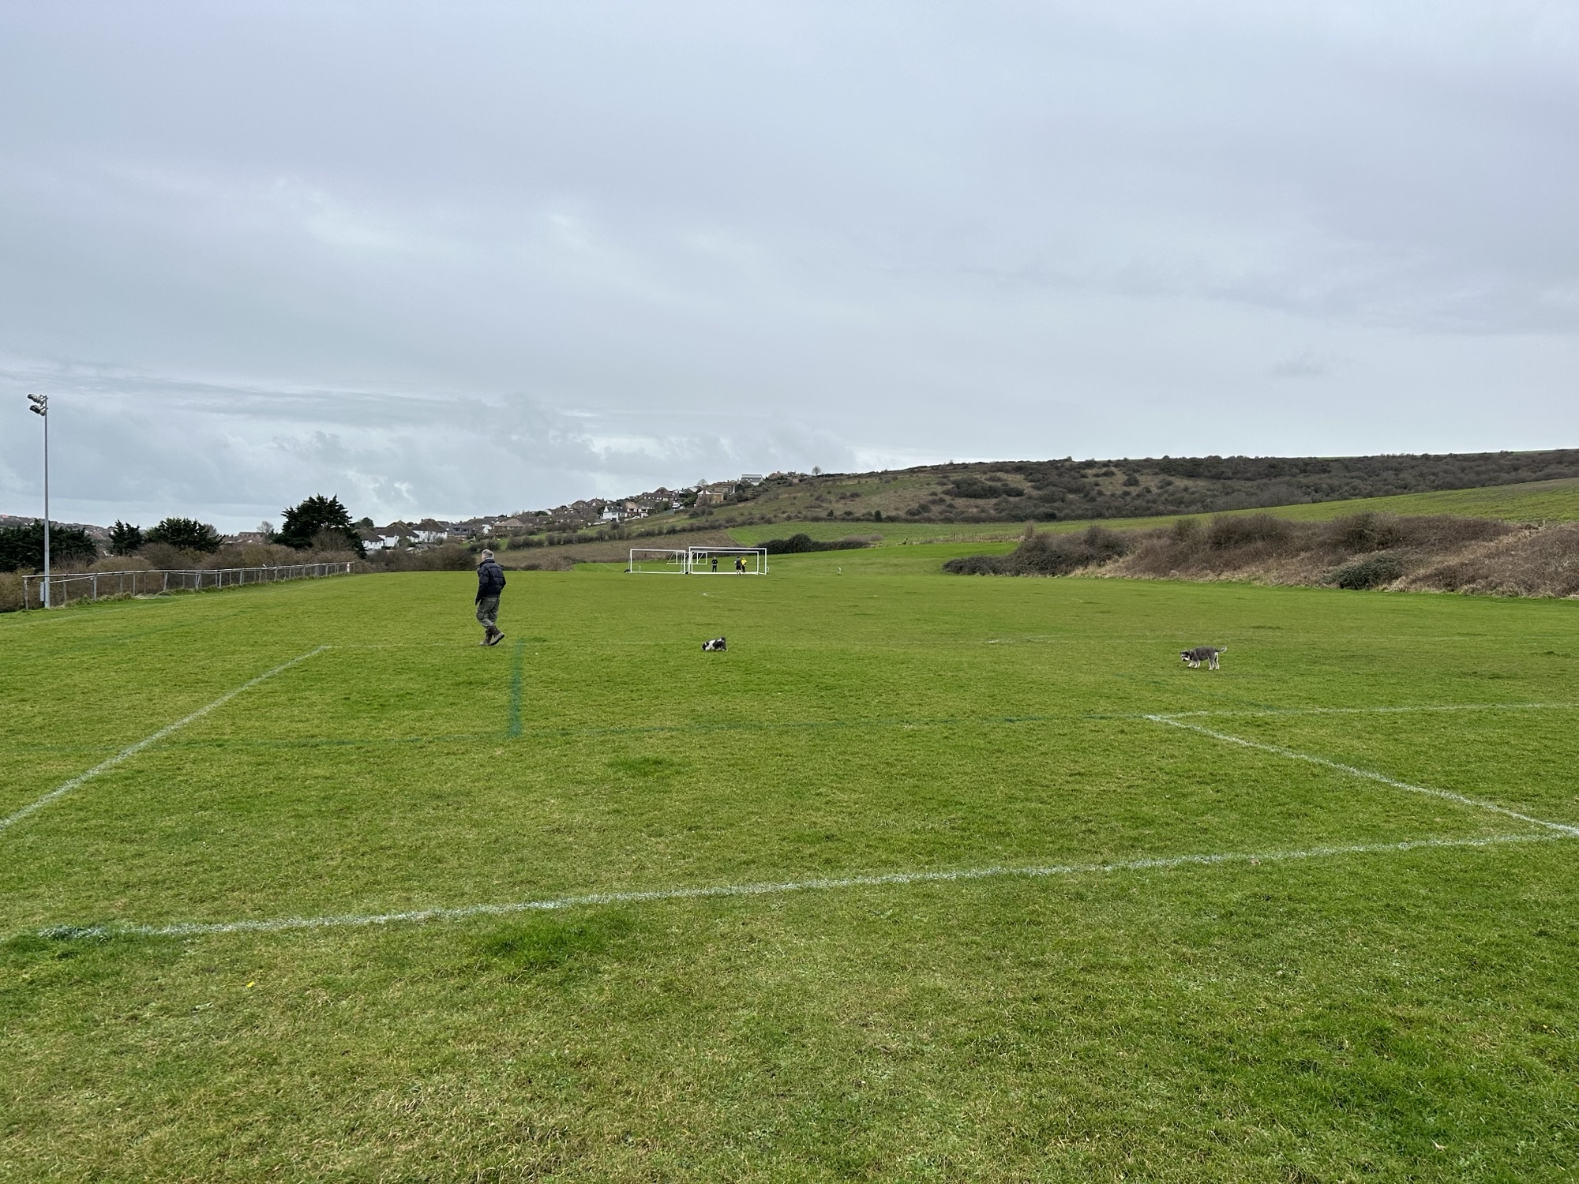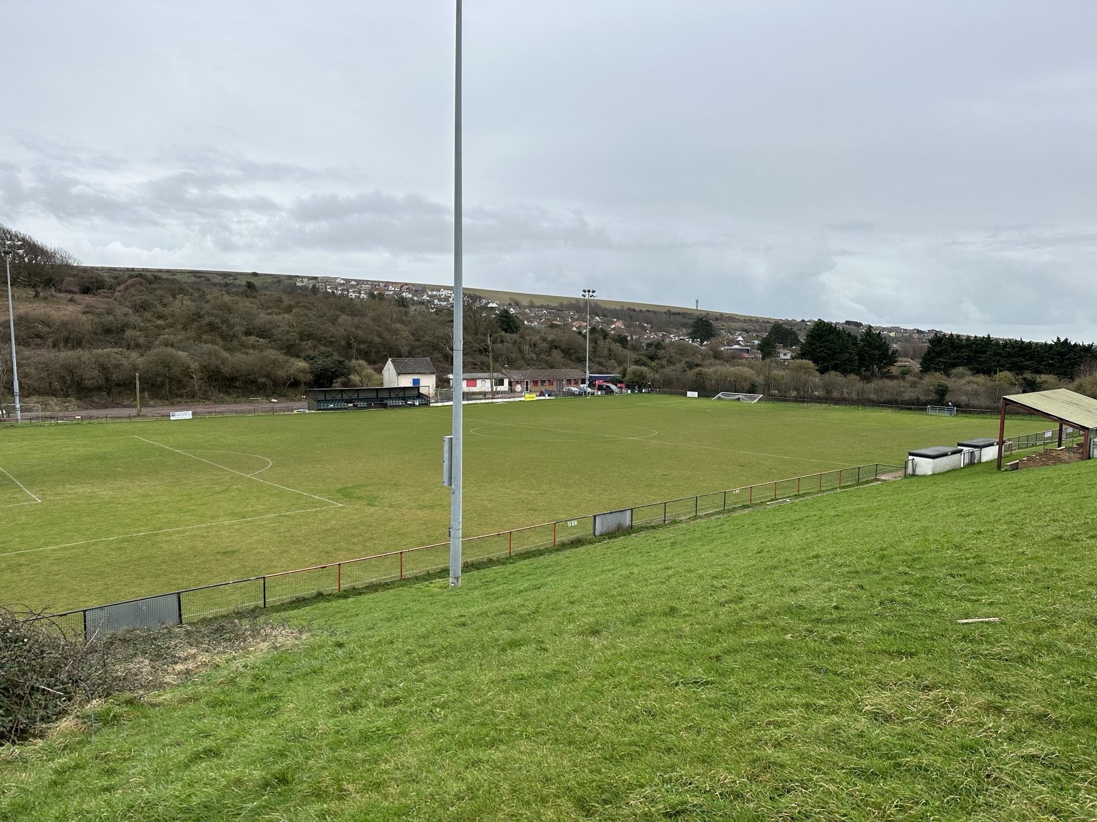
Aerial photo map or plan showing accurate boundary of site.
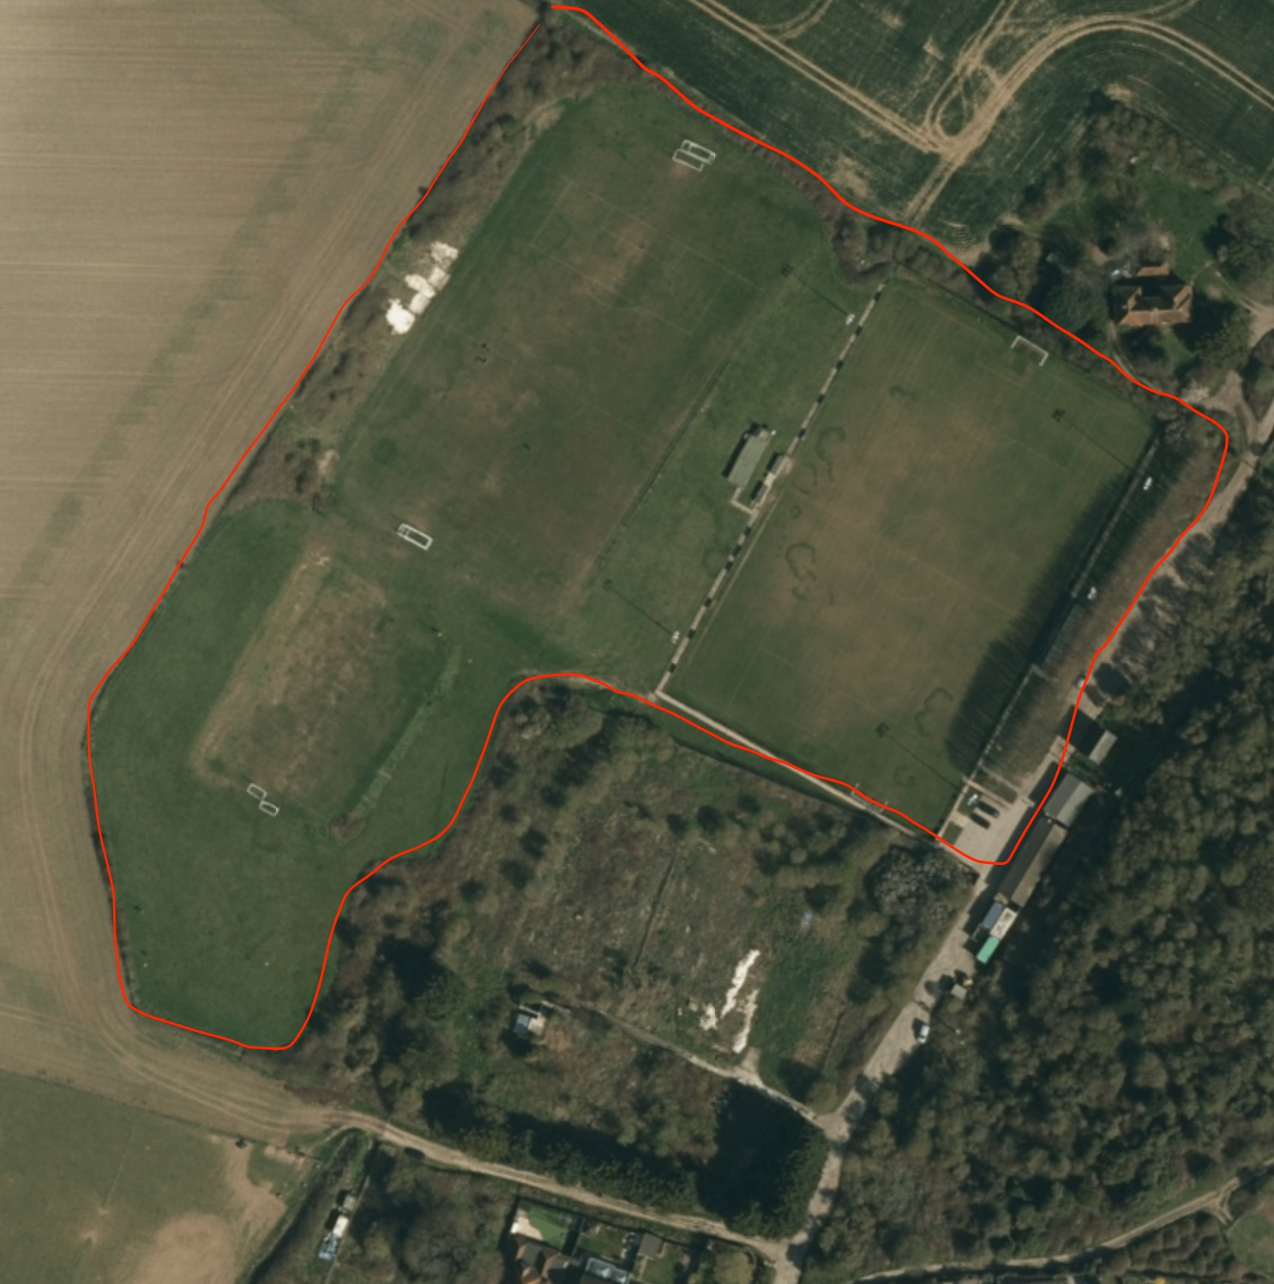

SITE 2 – Looes Barn Close. Land behind.

Site Name and Address (location) | Grid Ref
Behind Looes Barn Close | 50 degrees 48’49”N  0 degrees 2’ 6”W
Site owner | BHCC
Have they been informed / discussed? | Yes
Description and purpose / current use: | Unmaintained scrubland with trees
Statutory designations (eg SSSI) | None
Other designations (eg LNR) | None
Site allocations in Local Plan | No
Planning permission | Refused for houses
Access & proximity including how close to the community it serves (in meters) | Directly behind homes
List any public rights of way to or across the site: | None. Access currently through track owned by Farmer Carr family
Which of the following criteria does it meet? | Fully / Partially / Not (if F or P provide details)
- Beauty | F
- Historic significance / heritage | N
- Recreational value | N
- Tranquility | F
- Wildlife | F

Local in character – how would you describe for this statement?
Wildlife. Badgers set. Remains of a Bronze Age Burial.
Area (in hectares) | 1.1
Photograph
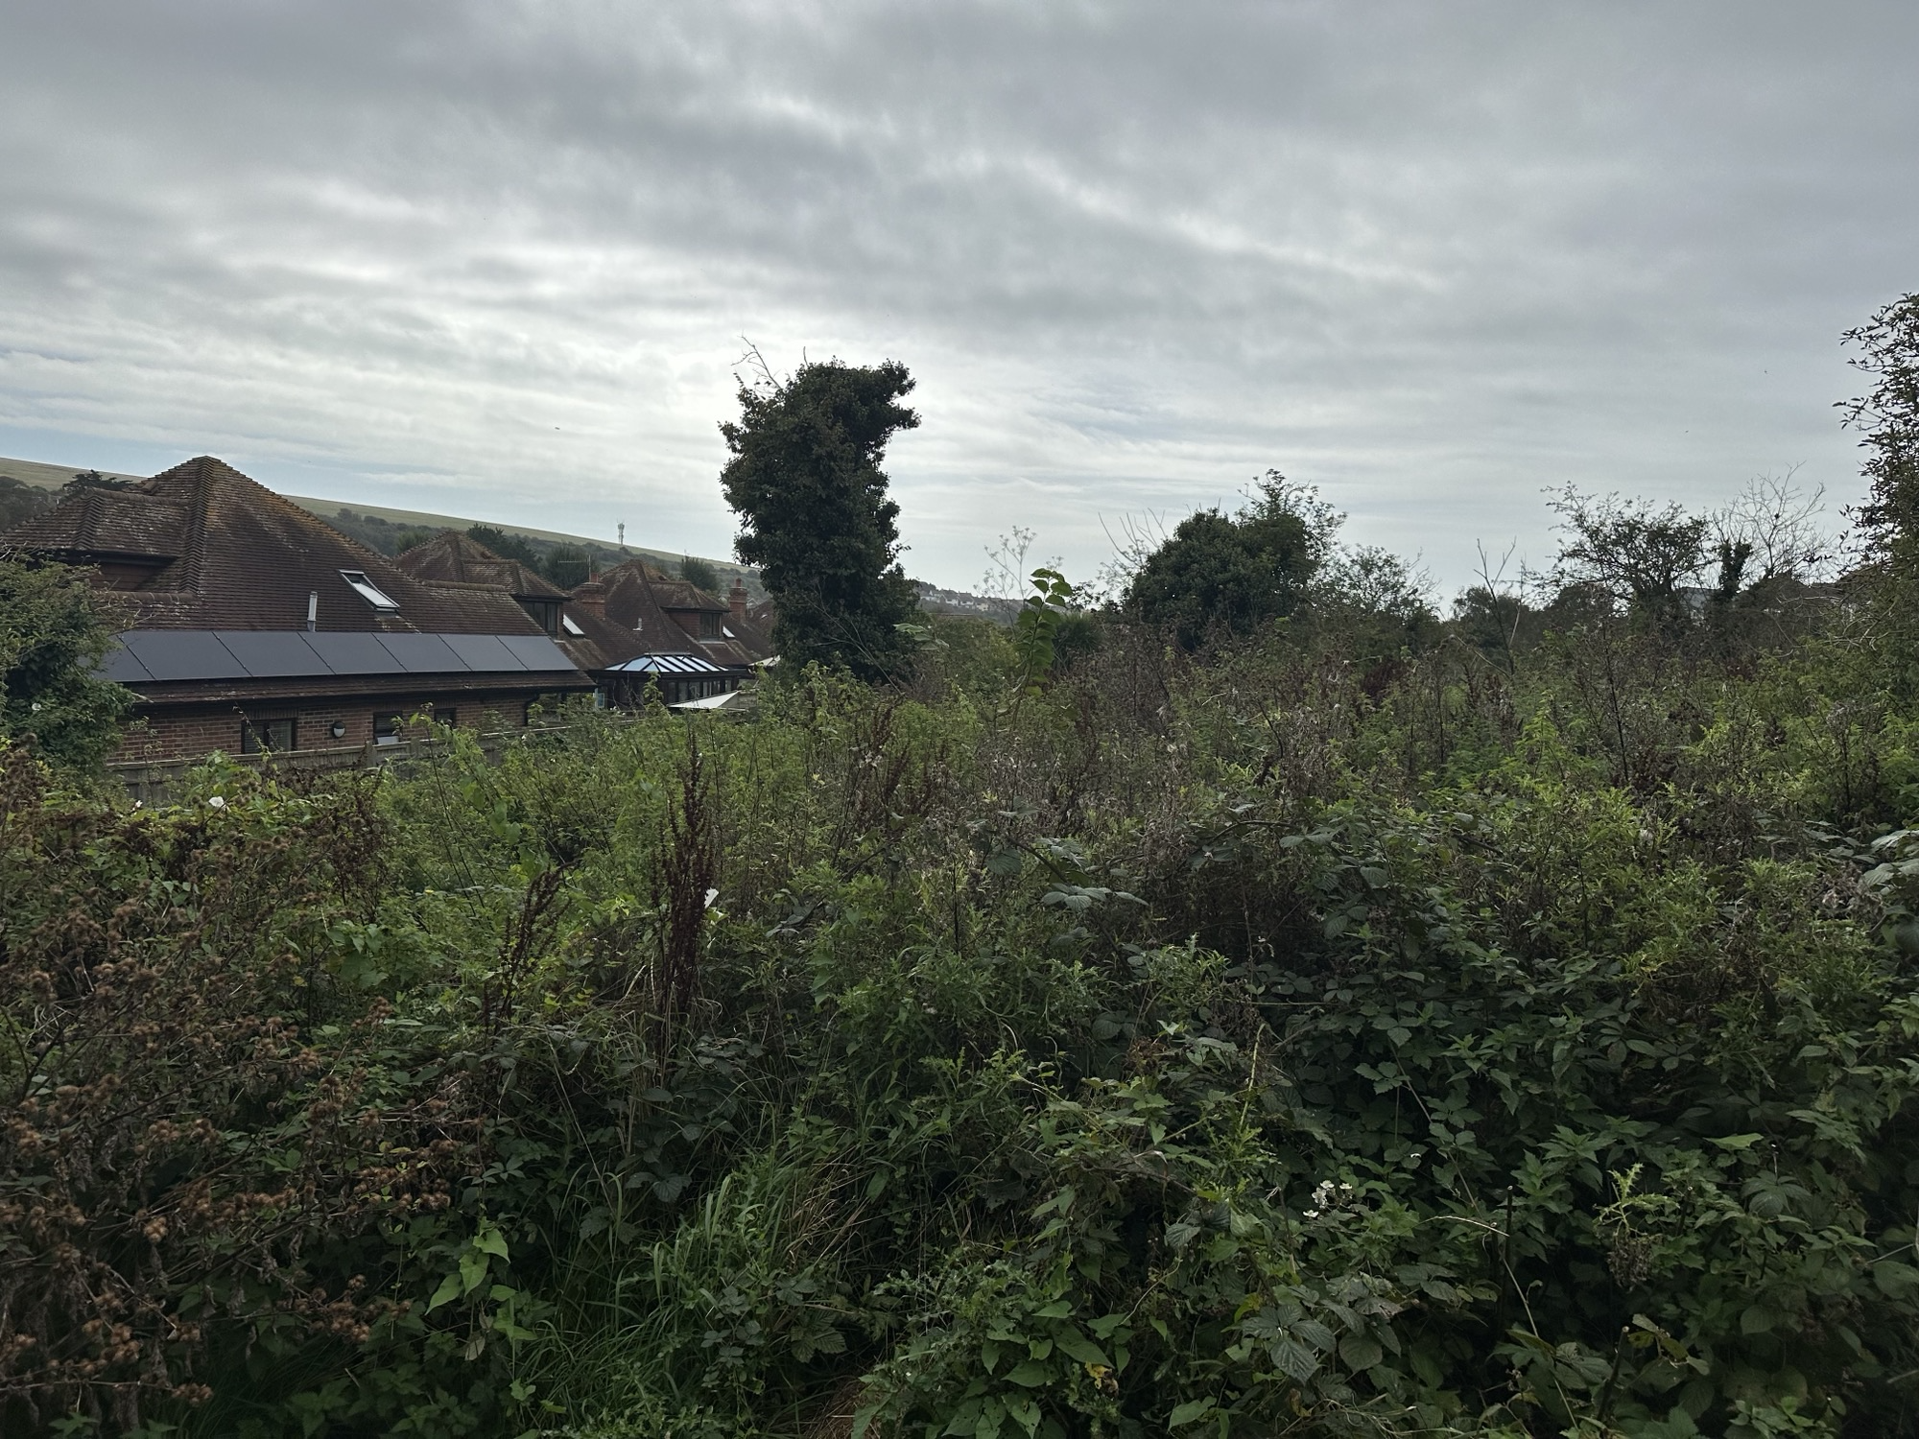
Aerial photo map or plan showing accurate boundary of site

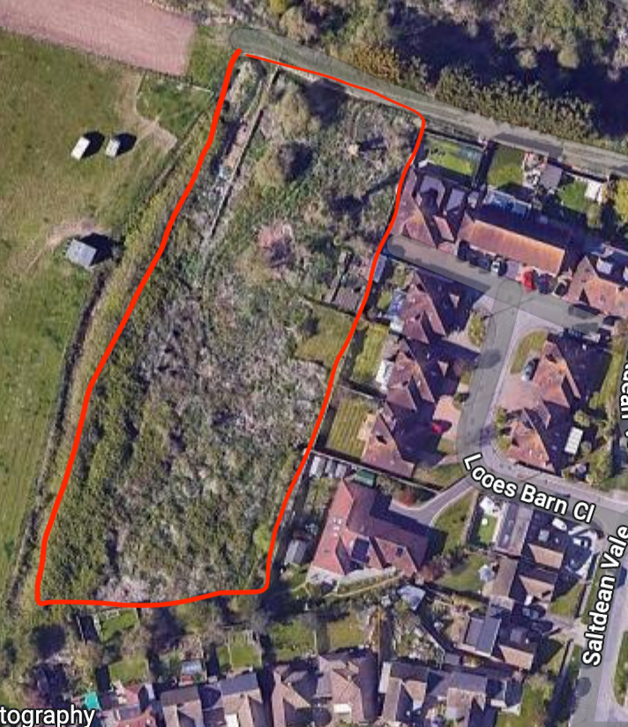

SITE 3 – Westfield Avenue North and South

Date of assessment: Assessors:

Site Name and Address (location) | Grid Ref
Westfield Avenue North and South
BN2 8HS
BN2 8HT

Site owner (if known) | BHCC
Have they been informed / discussed? | No
Description and purpose / current use: | Grass, trees, wildlife, picnicking, walking, games
Statutory designations (eg SSSI) | None
Other designations (eg LNR) | None
Site allocations in Local Plan | No
Planning permission | No
Access & proximity including how close to the community it serves (in meters) | open access. Surrounded by houses.
List any public rights of way to or across the site: | Open to public on all sides.
Which of the following criteria does it meet? | Fully / Partially / Not (if F or P provide details)
- Beauty | F
- Historic significance / heritage | F
- Recreational value | F
- Tranquility | F
- Wildlife | F

Local in character – how would you describe for this statement?
Open public space which is part of the original Saltdean estate.
Area (in hectares) | 1.2
Photograph
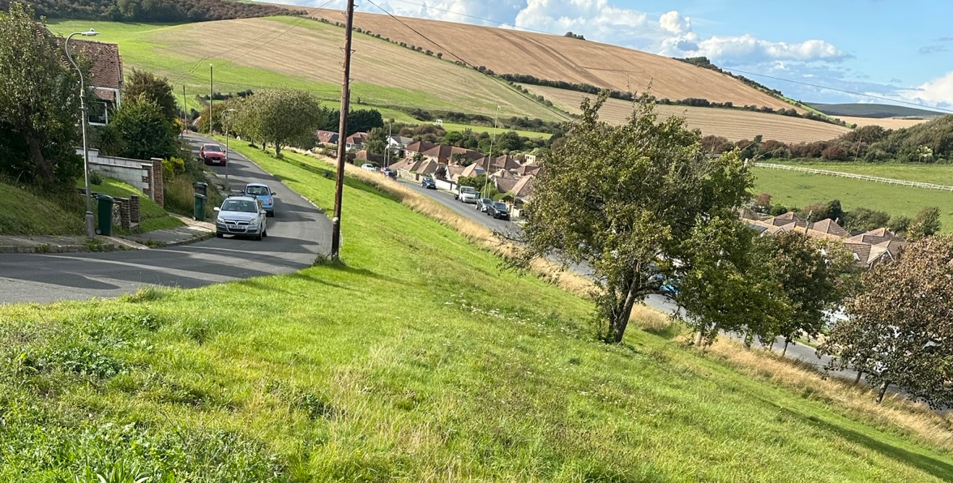
Aerial photo map or plan showing accurate boundary of site.
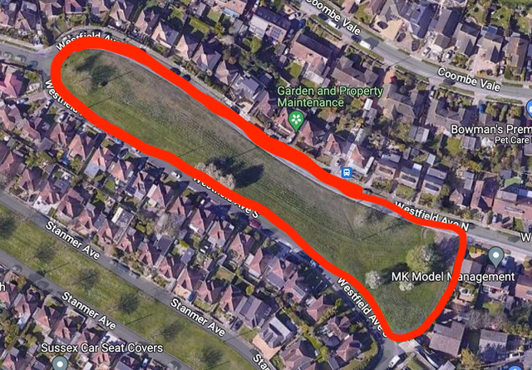

SITE 4 – Coombe Farm new housing estate

Site Name and Address (location) | Grid Ref
Site formerly part of Coombe Farm | Not possible to access to obtain
Site owner (if known) | The Man Group
Have they been informed / discussed? | Yes
Description and purpose / current use: | Open green space as part of new housing development
Statutory designations (eg SSSI) | None
Other designations (eg LNR) | None
Site allocations in Local Plan | Yes
Planning permission | BH2020/00002 granted  72 homes currently being built (Jan 2024) with estimated completion date of Jan 2025
Access & proximity including how close to the community it serves (in meters) | Will be open access. Surrounded by homes
List any public rights of way to or across the site: | Will be open to public
Which of the following criteria does it meet? | Fully / Partially / Not (if F or P provide details)
- Beauty | F
- Historic significance / heritage | N
- Recreational value | F
- Tranquility | P
- Wildlife | P

Local in character – how would you describe for this statement?
Area (in hectares) | 0.5
Photograph
Not possible to access to obtain
Aerial photo map or plan showing accurate boundary of site.
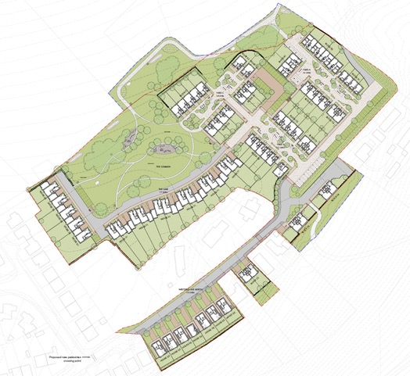

SITE 5 – Hailsham Avenue

Site Name and Address (location) | Grid Ref
Hailsham Avenue  BN2 8QH | 50°49’40”N  0°2’2”W
Site owner (if known) | BHCC
Have they been informed / discussed? | Yes
Description and purpose / current use: | Grass, trees, wildlife, picnicking, walking, games
Statutory designations (eg SSSI) | None
Other designations (eg LNR) | None
Site allocations in Local Plan | No
Planning permission | n/a
Access & proximity including how close to the community it serves (in meters) | open access. Surrounded by homes/
List any public rights of way to or across the site: | open to all on all sides.
Which of the following criteria does it meet? | Fully / Partially / Not (if F or P provide details)
- Beauty | F
- Historic significance / heritage | F
- Recreational value | F
- Tranquility | F
- Wildlife | F
Local in character – how would you describe for this statement?
Open public space which is part of the original Saltdean estate.
Area (in hectares) | 0.5
Photograph
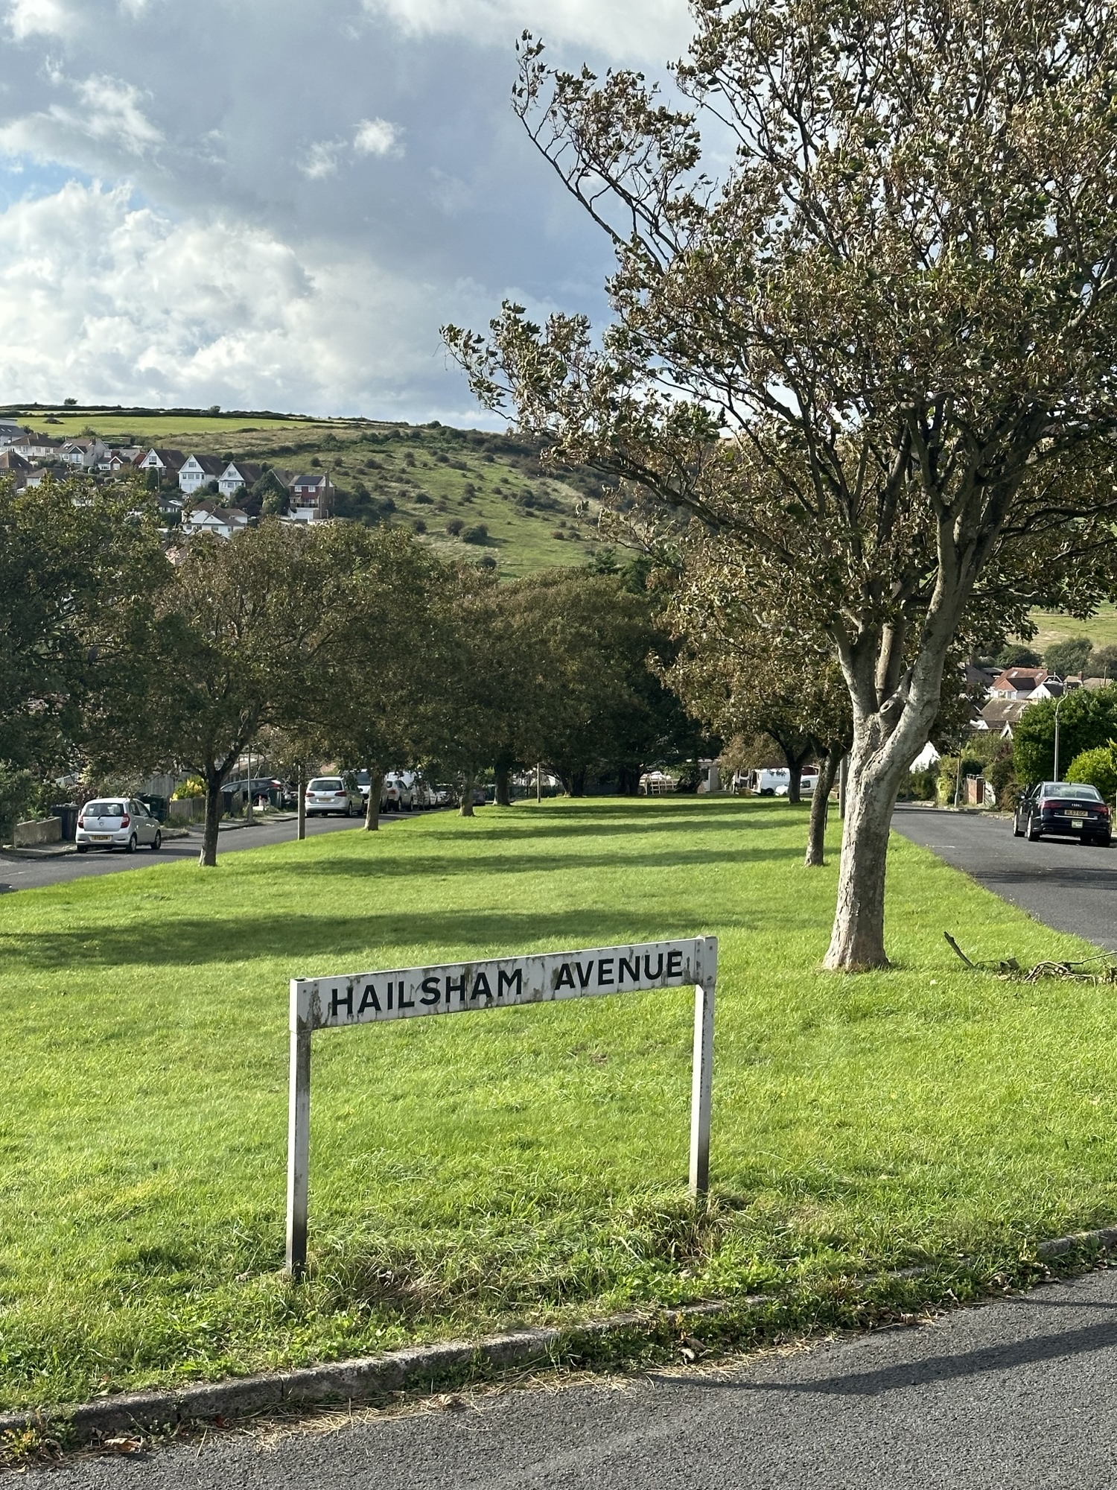
Aerial photo map or plan showing accurate boundary of site.
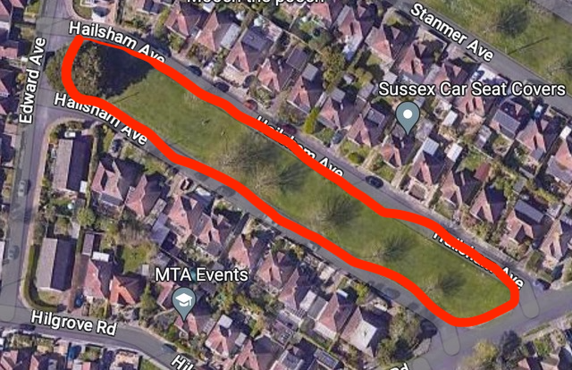

SITE 6 – Stanmer Avenue

Site Name and Address (location) | Grid Ref
Stanmer Avenue  BN2 8QL | 50°48’42”N  0°1’60”
Site owner | BHCC
Have they been informed / discussed? | Yes
Description and purpose / current use: | Grass, trees, wildlife, picnicking, walking, games
Statutory designations (eg SSSI) | None
Other designations (eg LNR) | None
Site allocations in Local Plan | No
Planning permission | n/a
Access & proximity including how close to the community it serves (in meters) | Surrounded by homes.
List any public rights of way to or across the site: | Open access
Which of the following criteria does it meet? | Fully / Partially / Not (if F or P provide details)
- Beauty | F
- Historic significance / heritage | P
- Recreational value | F
- Tranquility | F
- Wildlife | F
Local in character – how would you describe for this statement?
Open public space which is part of the original Saltdean estate. Trees. Grass.
Birds and foxes found here.
Area (in hectares) | 0.7
Photograph
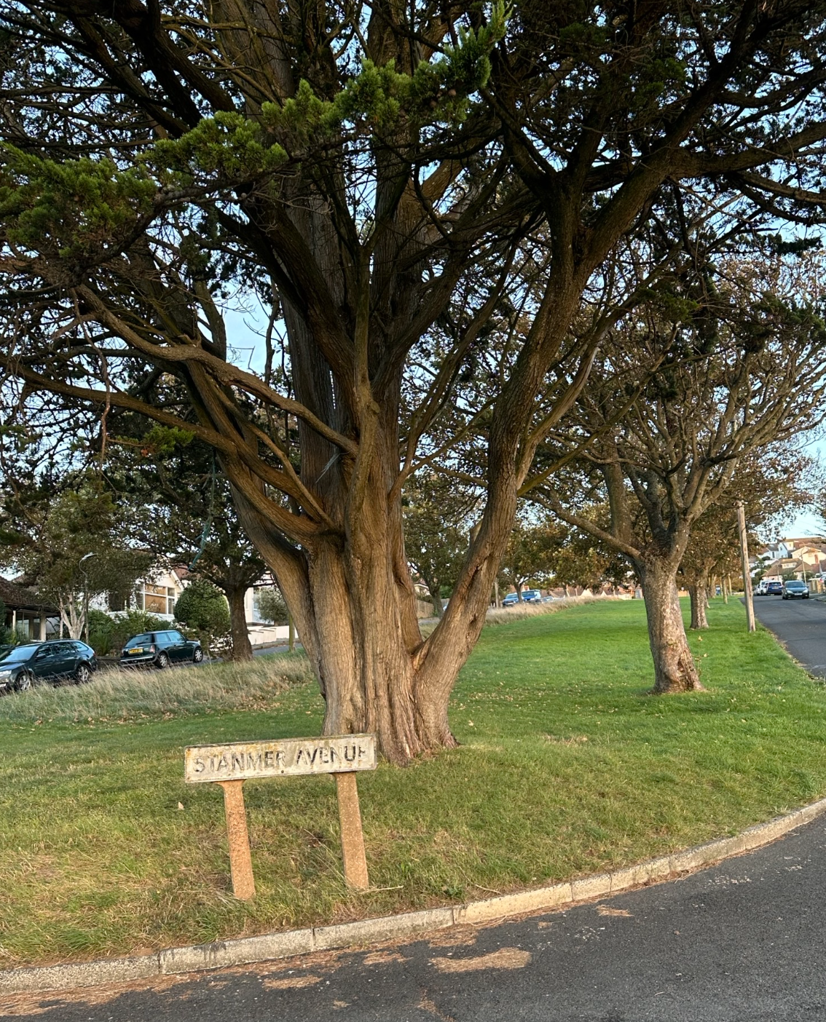
Aerial photo map or plan showing accurate boundary of site.
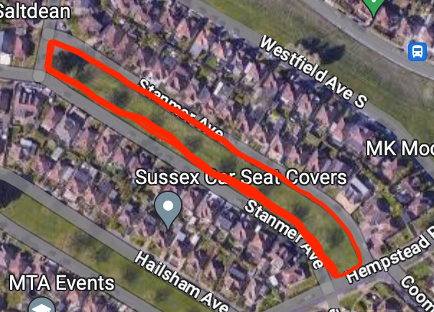

SITE 7 – Hempstead Road

Date of assessment: Assessors:

Site Name and Address (location) | Grid Ref
Hempstead Road  BN2 8QD | 50° 35” N  0° 2’ 6” W
Site owner (if known) | BHCC
Have they been informed / discussed? | Yes
Description and purpose / current use: | Grass, trees, wildlife, picnicking, walking, games
Statutory designations (eg SSSI) | None
Other designations (eg LNR) | None
Site allocations in Local Plan | No
Planning permission | n/a
Access & proximity including how close to the community it serves (in meters) | Surrounded by homes.
List any public rights of way to or across the site: | Open access on all sides.
Which of the following criteria does it meet? | Fully / Partially / Not (if F or P provide details)
- Beauty | F
- Historic significance / heritage | F
- Recreational value | F
- Tranquility | F
- Wildlife | F
Local in character – how would you describe for this statement?
Open public space which is part of the original Saltdean estate.
Area (in hectares) | 0.3
Photograph
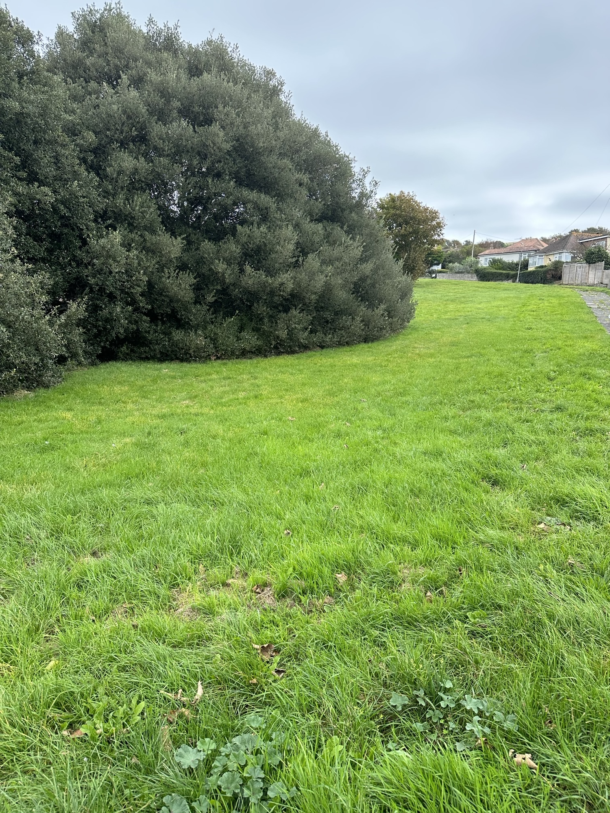
Aerial photo map or plan showing accurate boundary of site.
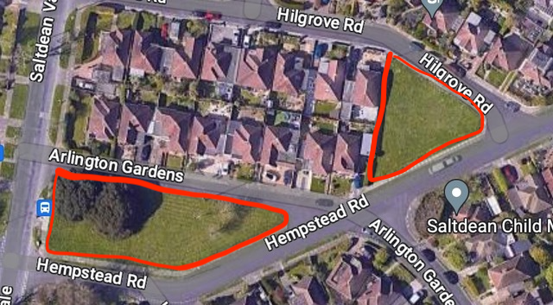

SITE 8 - Mount Estate Plot 1

Site Name and Address (location) | Grid Ref
Mount Estate – plot 1  Bordered by Saltdean Vale, Hempstead Road and Mount Drive | 50°48’31”N  0°2’6”W
Site owner | Acquired by CIC September 2023
Have they been informed / discussed? | Yes
Description and purpose / current use: | Established open space protected by a covenant. Registered as Asset of Community Value.
Statutory designations (eg SSSI) | None
Other designations (eg LNR) | None
Site allocations in Local Plan | No
Planning permission | Na
Access & proximity including how close to the community it serves (in meters) | Surrounded by homes
List any public rights of way to or across the site: | Full
Which of the following criteria does it meet? | Fully / Partially / Not (if F or P provide details)
- Beauty | P
- Historic significance / heritage | N
- Recreational value | F
- Tranquility | P
- Wildlife | F
Local in character – how would you describe for this statement?
Grassland, scrub, bramble, trees
Badges, foxes, birds and insects
Part of original Saltdean estate

Area (in hectares) | 0.8
Photograph
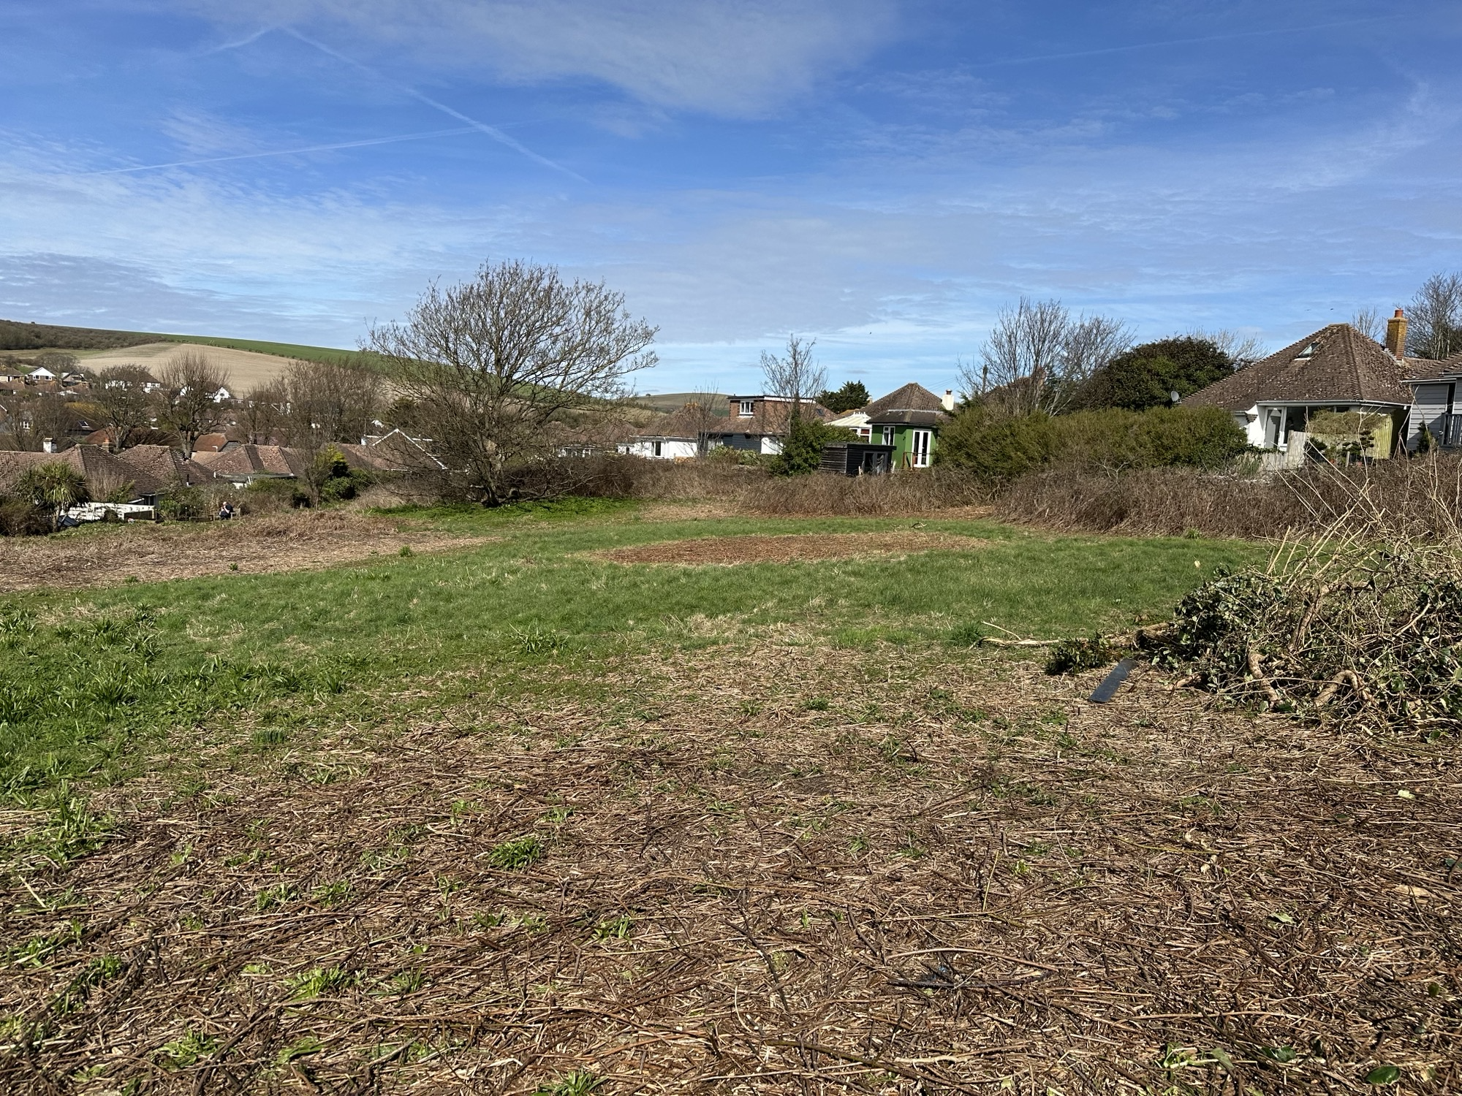
Aerial photo map or plan showing accurate boundary of site.
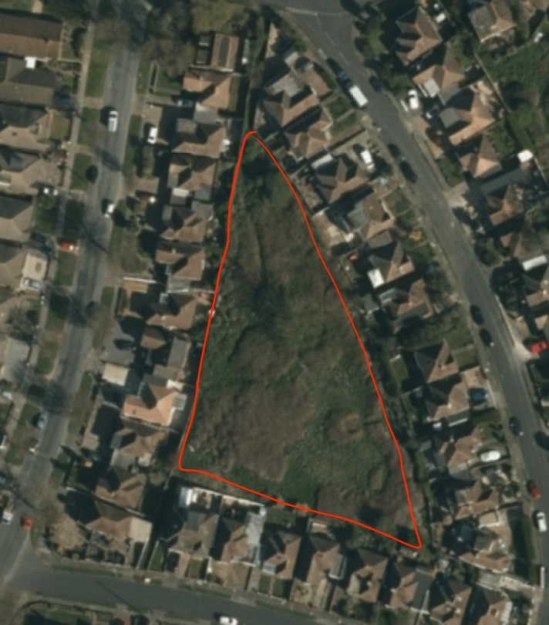

SITE 9 - Mount Estate Plot 2

Site Name and Address (location) | Grid Ref
Mount Estate – plot 2
Bordered by Heathfield Avenue, Arlington Avenue, Greenbank and Hempstead Road
Site owner | Unknown.
Have they been informed / discussed? | Yes via auction agent.
Description and purpose / current use: | Established open space surrounded by homes with narrow entrance points
Statutory designations (eg SSSI) | None
Other designations (eg LNR) | Established open space protected by a covenant. Registered as Asset of Community Value.
Site allocations in Local Plan | No
Planning permission | Na
Access & proximity including how close to the community it serves (in meters) | Surrounded by homes.
List any public rights of way to or across the site: | Full
Which of the following criteria does it meet? | Fully / Partially / Not (if F or P provide details)
- Beauty | P
- Historic significance / heritage | N
- Recreational value | F
- Tranquility | P
- Wildlife | F
Local in character – how would you describe for this statement?
Grassland, scrub, bramble, trees
Badges, foxes, birds and insects
Part of original Saltdean estate

Area (in hectares) | c0.8
Photograph
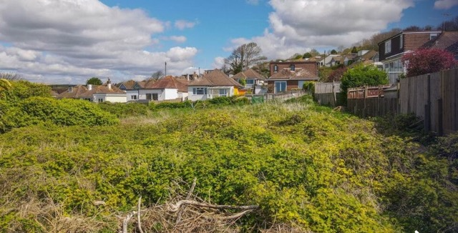
Aerial photo map or plan showing accurate boundary of site.
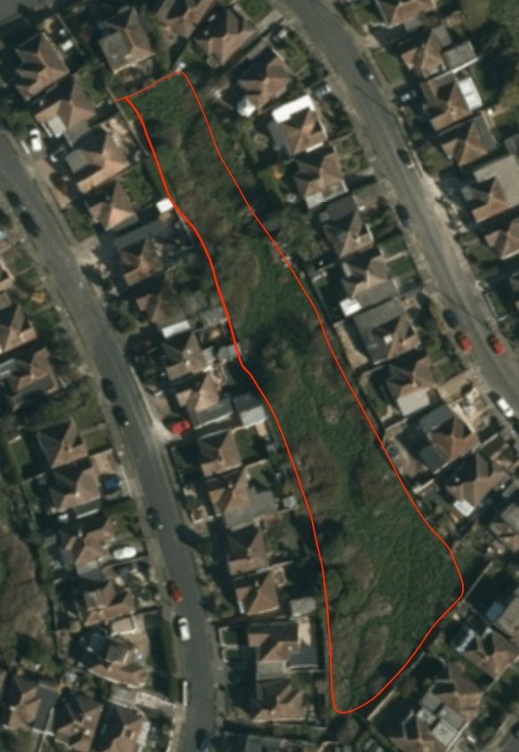

SITE 10 - Mount Estate Plot 3

Site Name and Address (location) | Grid Ref
Mount Estate – plot 3  Bordered by Greenbank, Berwick Road and Arlington Gardens | 50°48’33” N  0° 1’ 5” W
Site owner | Hadley estates
Have they been informed / discussed? | Yes via land agent
Description and purpose / current use:
Statutory designations (eg SSSI) | Established open space protected by a covenant. Registered as Asset of Community Value.
Other designations (eg LNR) | None
Site allocations in Local Plan | No
Planning permission | 3 houses refused by inspector in 2017
Access & proximity including how close to the community it serves (in meters) | Surrounded by houses on two sides
List any public rights of way to or across the site: | Full
Which of the following criteria does it meet? | Fully / Partially / Not (if F or P provide details)
- Beauty | P
- Historic significance / heritage | N
- Recreational value | F
- Tranquility | P
- Wildlife | F
Local in character – how would you describe for this statement?
Grassland, scrub, bramble, trees
Badges, foxes, birds and insects
Part of original Saltdean estate

Area (in hectares) | 0.8
Photograph
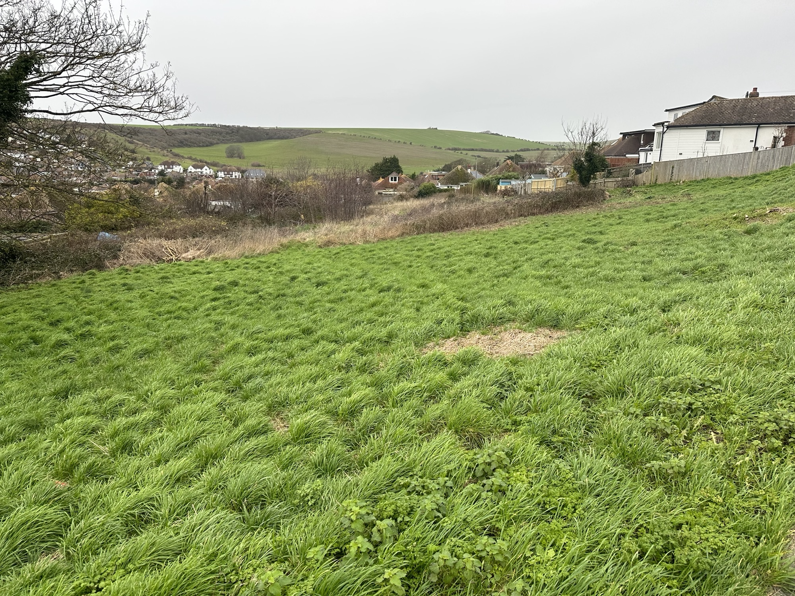
Aerial photo map or plan showing accurate boundary of site.
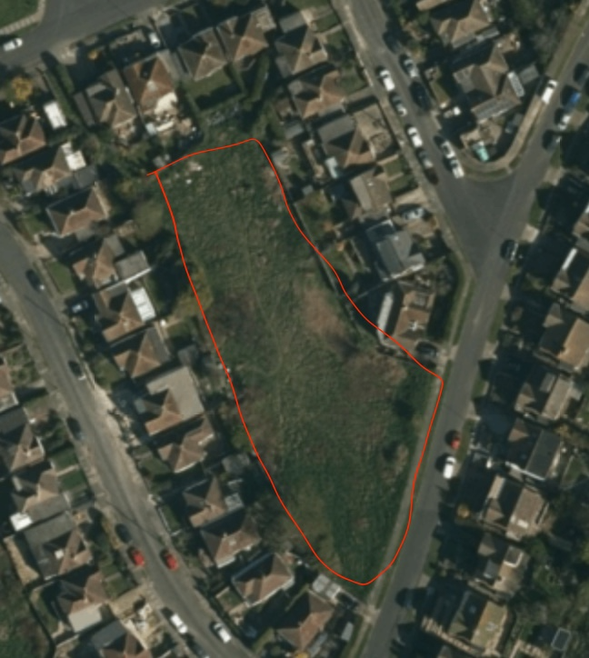

SITE 11 - Saltdean Primary School

Site Name and Address (location) | Grid Ref
Saltdean Primary School  Chiltington Way  BN2 8HB | 50°48’31”N  0°2’21”W
Site owner | BHCC
Have they been informed / discussed? | Yes
Description and purpose / current use: | School playing fields
Statutory designations (eg SSSI) | None
Other designations (eg LNR) | None
Site allocations in Local Plan | No
Planning permission | No
Access & proximity including how close to the community it serves (in meters) | Private land
List any public rights of way to or across the site: | None
Which of the following criteria does it meet? | Fully / Partially / Not (if F or P provide details)
- Beauty | F Sea and countryside views
- Historic significance / heritage | F The historic heart of West Saltdean
- Recreational value | F. See existing amenities. Also walking
- Tranquility | P Well-used by humans so can be noisy
- Wildlife | F Birds, foxes, insects
Local in character – how would you describe for this statement?
School playing fields

Area (in hectares) | 0.8
Photograph
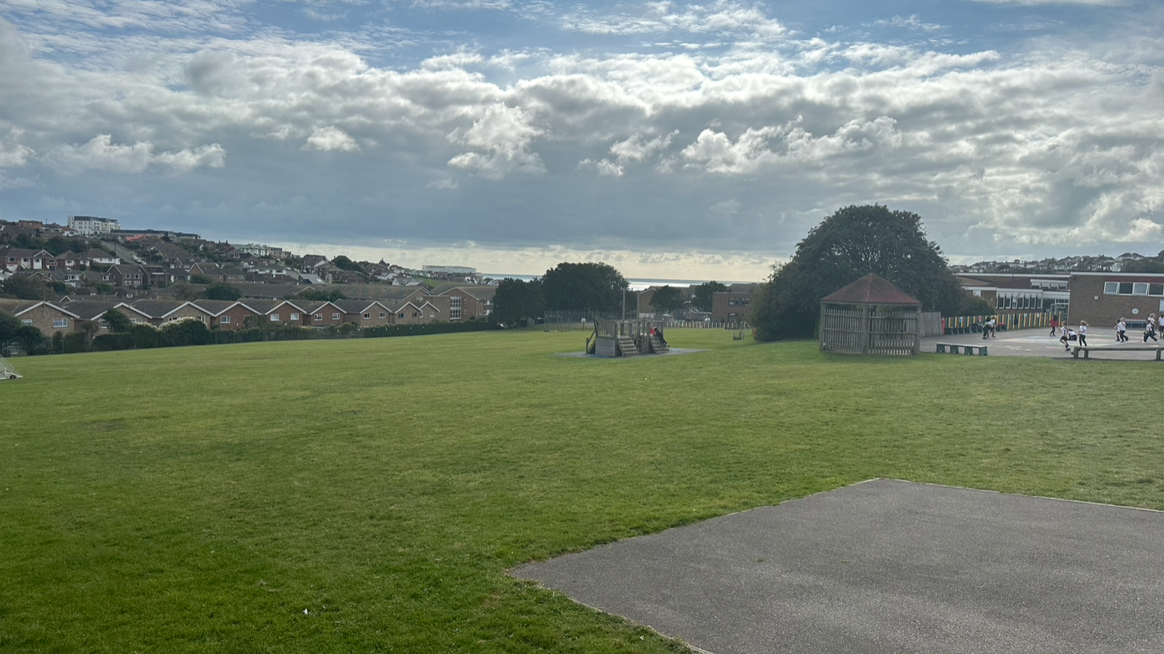
Aerial photo map or plan showing accurate boundary of site.
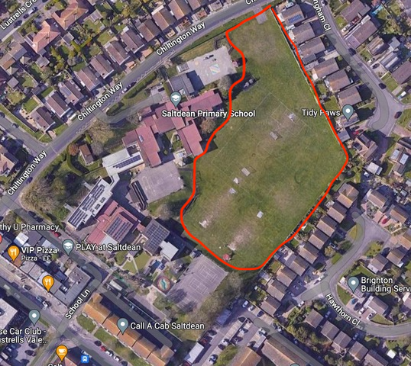

SITE 12 – St Nicholas Church

Site Name and Address (location) | Grid Ref

St Nicholas’ Church, Saltdean Vale

Site owner | BHCC
Have they been informed / discussed? | Yes
Description and purpose / current use: | church, church hall and small grassy area surrounding both that is accessible to the public.
Statutory designations (eg SSSI) | None
Other designations (eg LNR) | None
Site allocations in Local Plan | No
Planning permission | Na
Access & proximity including how close to the community it serves (in meters) | Houses on two sides.
List any public rights of way to or across the site: | Full
Which of the following criteria does it meet? | Fully / Partially / Not (if F or P provide details)
- Beauty | P
- Historic significance / heritage | N
- Recreational value | F
- Tranquility | P
- Wildlife | F
Local in character – how would you describe for this statement?
Grounds of church. No graves.

Area (in hectares) | 0.8
Photograph
Aerial photo map or plan showing accurate boundary of site.
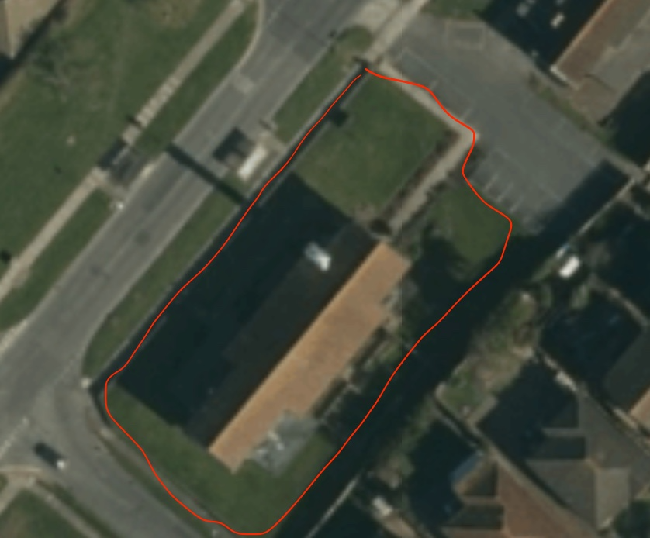

SITE 13 – Saltdean Vale

Saltdean Vale  Postcode: BN2 8HA  Three open grassy areas. Southern end opposite church, below Lustrells Vale junction | Grid Ref:  50°48’17” N  0° 2’ 24” W
Site owner | BHCC
Have they been informed / discussed? | Yes
Description and purpose / current use: | trees, stumps and grass. Desire path.
Statutory designations (eg SSSI) | None
Other designations (eg LNR) | None
Site allocations in Local Plan | No
Planning permission | n/a
Access & proximity including how close to the community it serves (in meters) | open access
List any public rights of way to or across the site: | Desire path. Pavements on the perimeter
Which of the following criteria does it meet? | Fully / Partially / Not (if F or P provide details)
- Beauty | F
- Historic significance / heritage | F
- Recreational value | F
- Tranquility | P
- Wildlife | F
Local in character – how would you describe for this statement?
Three open public spaces besides main through road – Saltdean Vale - which are part of the original Saltdean estate.

Birds and foxes.

Trees and tree stumps.

Area (in hectares) | 0.4
Photograph
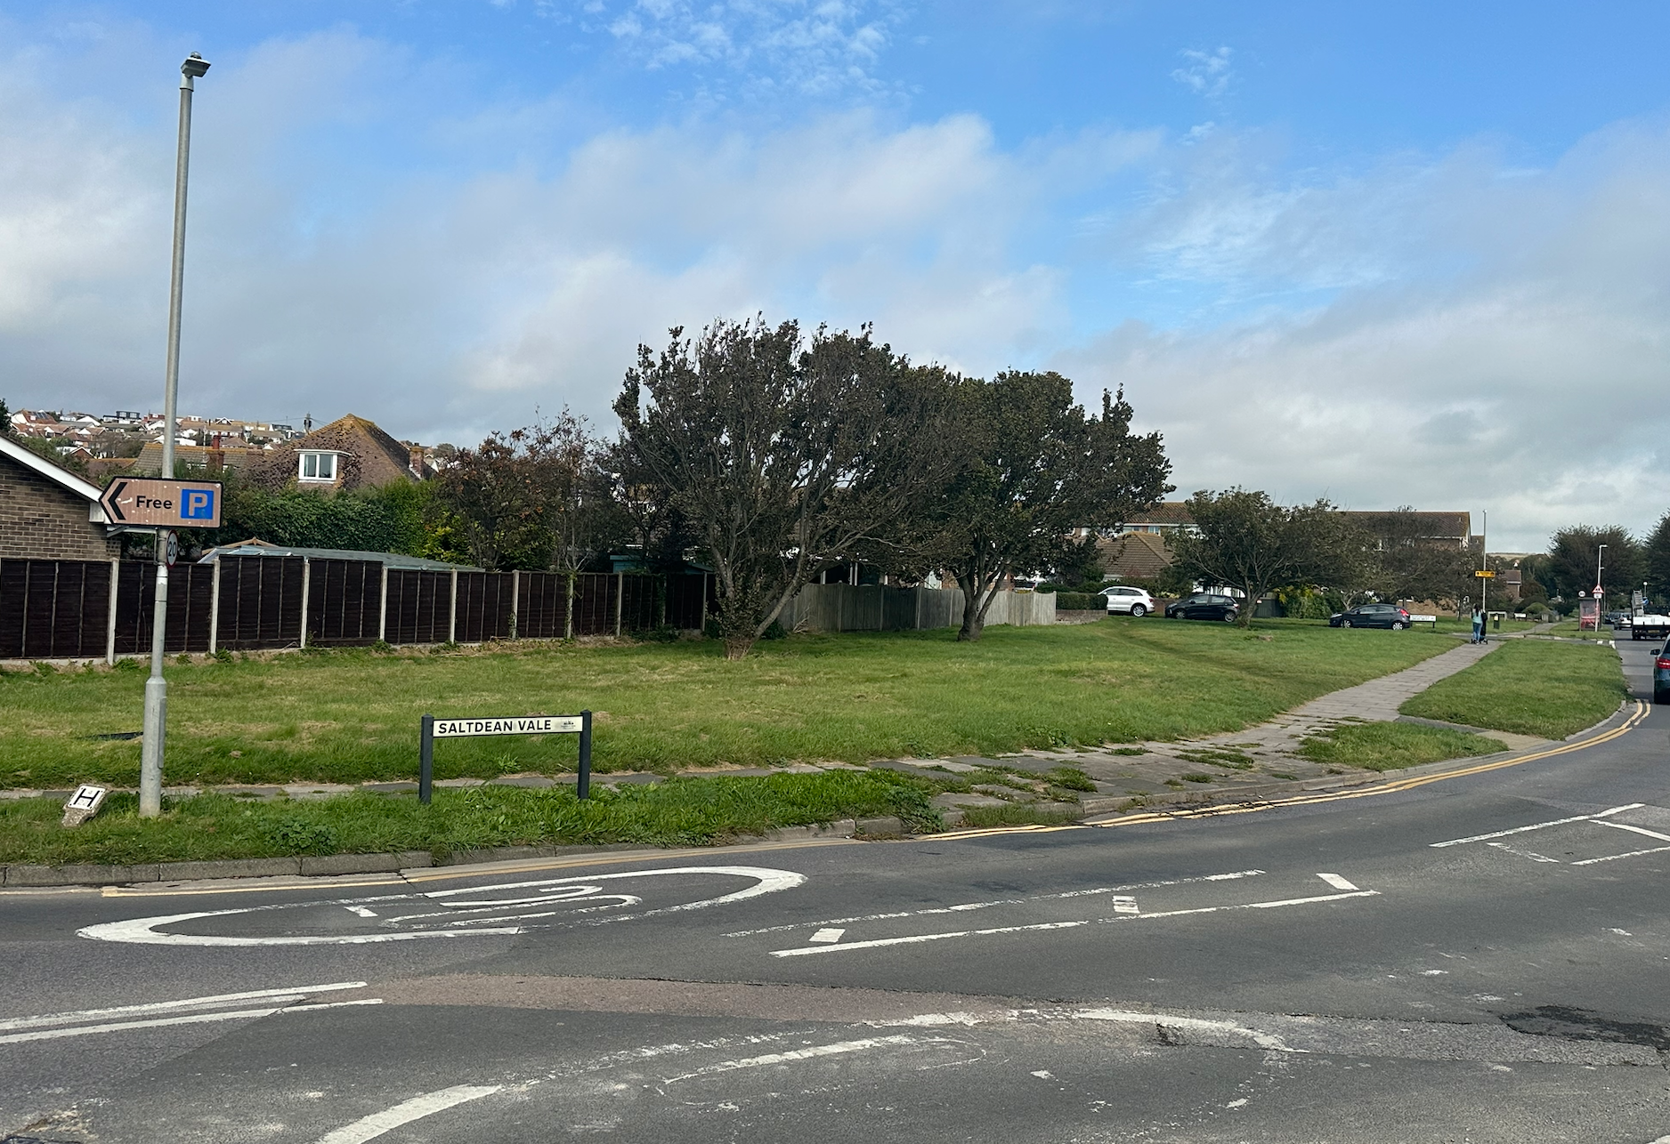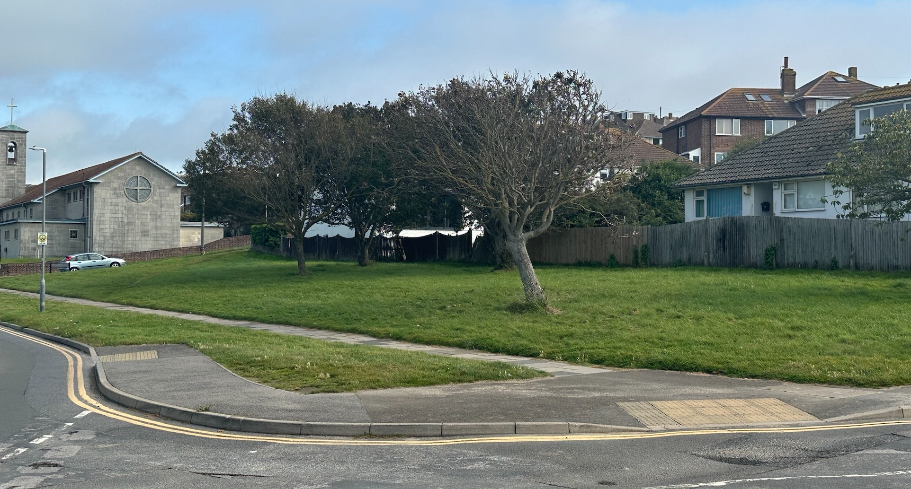
Aerial photo map
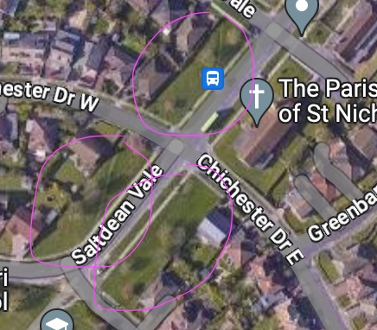

SITE 14 - Saltdean Oval Park

Site Name and Address (location) | Grid Ref
Saltdean Oval Park | 50°48’10”N  0°2’29”W
Site owner | BHCC
Have they been informed / discussed? | Yes
Description and purpose / current use: | Public park enclosed by metal fencing and hedges
Statutory designations (eg SSSI) | Asset of Community Value  Sports pitches are protected in the NPPF paragraph 99
Other designations (eg LNR) | None
Site allocations in Local Plan | No
Planning permission | Na
Access & proximity including how close to the community it serves (in meters) | Surrounded by roads, then homes
List any public rights of way to or across the site: | Full
Which of the following criteria does it meet? | Fully / Partially / Not (if F or P provide details)
- Beauty | P
- Historic significance / heritage | N
- Recreational value | F
- Tranquility | P
- Wildlife | F
Local in character – how would you describe for this statement?
The green heart of West Saltdean.

Six hectares (18 acres) of Public Park with both mown and wild planting areas.

Registered as an Asset of Community Value (ACV) and has a covenant on it that prohibits buildings used for commercial use.

Trees
Small tree copses on the south and western verges.

Newly planted trees (March 2023) across the park

A hedge boundary apart from at the southern end.

Mature shrubbery borders around the bowls green.

The chalk grass slope has been used for an experiment by University of Sussex to grow wild flowers.

Amenities:
Playground, bowls green, tennis courts, skateboard park, outdoor gym, one marked-out football pitch used for practice and matches of the junior teams of Saltdean United Football Club, Multi-Use games area (MUGA), sports pavilion which houses two public toilets (m and f); two wooded areas.

The playground in Saltdean Oval Park was re-vamped in summer 2023. The MUGA and skateboard park also need refurbishing. 106 money has been set-aside for the MUGA with some additional local fundraising needed.

Home to two pre-school nurseries with private grounds: Gingerbread and Boomerang. In 2020, the owners of the former were refused permission for a new-build replacement building by BHCC as land-owner due to the covenant mentioned above.

It contains one privately-owned home with a garden, The Golf House.

Hosts a funfair and various community events in the summer.

Area (in hectares) | 6
Photograph
Aerial photo map or plan showing accurate boundary of site.
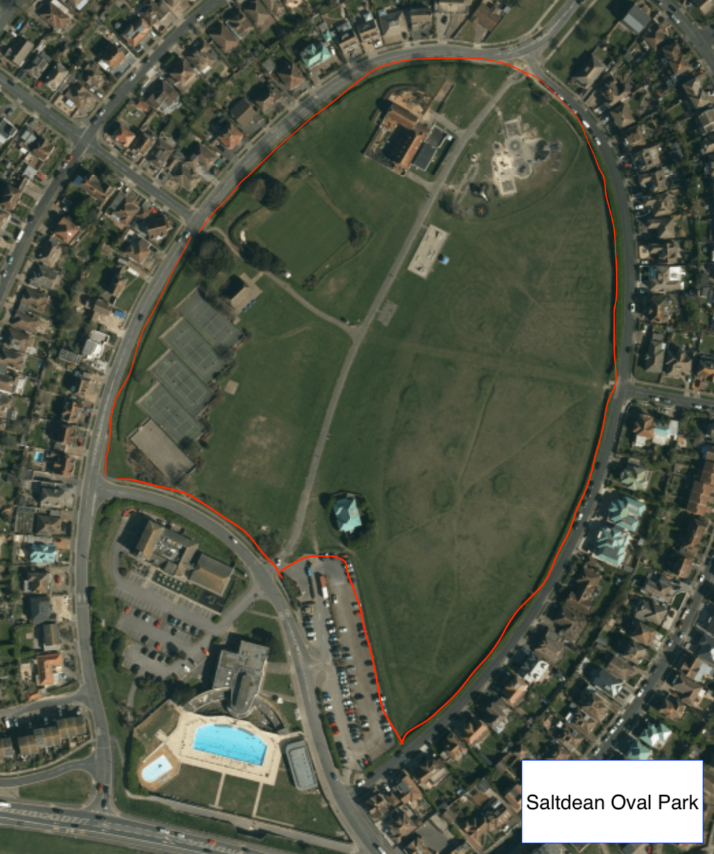

SITE 15 – Saltdean Lido

Site Name and Address (location) | Grid Ref
Saltdean Lido | 50°48’4”N  0°2’31”W
Site owner  Saltdean Lido CIC – leaseholder  BHCC - freehold | BHCC
Have they been informed / discussed? | Yes
Description and purpose / current use: | Green space surrounding the lido building and pool including a large grassy area to the south of the building accessible to paying customers only. Used for sunbathing and for events.
Statutory designations (eg SSSI) | Asset of Community Value
Other designations (eg LNR) | None
Site allocations in Local Plan | No
Planning permission | No
Access & proximity including how close to the community it serves (in meters) | Nearest homes 10 away.
List any public rights of way to or across the site: | Full
Which of the following criteria does it meet? | Fully / Partially / Not (if F or P provide details)
- Beauty | P
- Historic significance / heritage | N
- Recreational value | F
- Tranquility | P
- Wildlife | F
Local in character – how would you describe for this statement?
Area (in hectares) | 1
Photograph
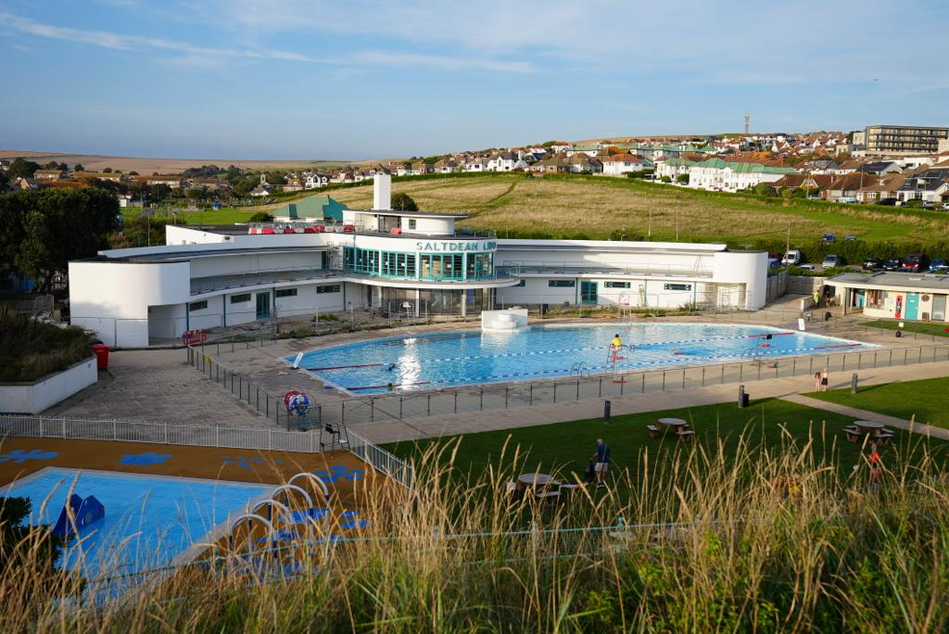
Aerial photo map or plan showing accurate boundary of site.
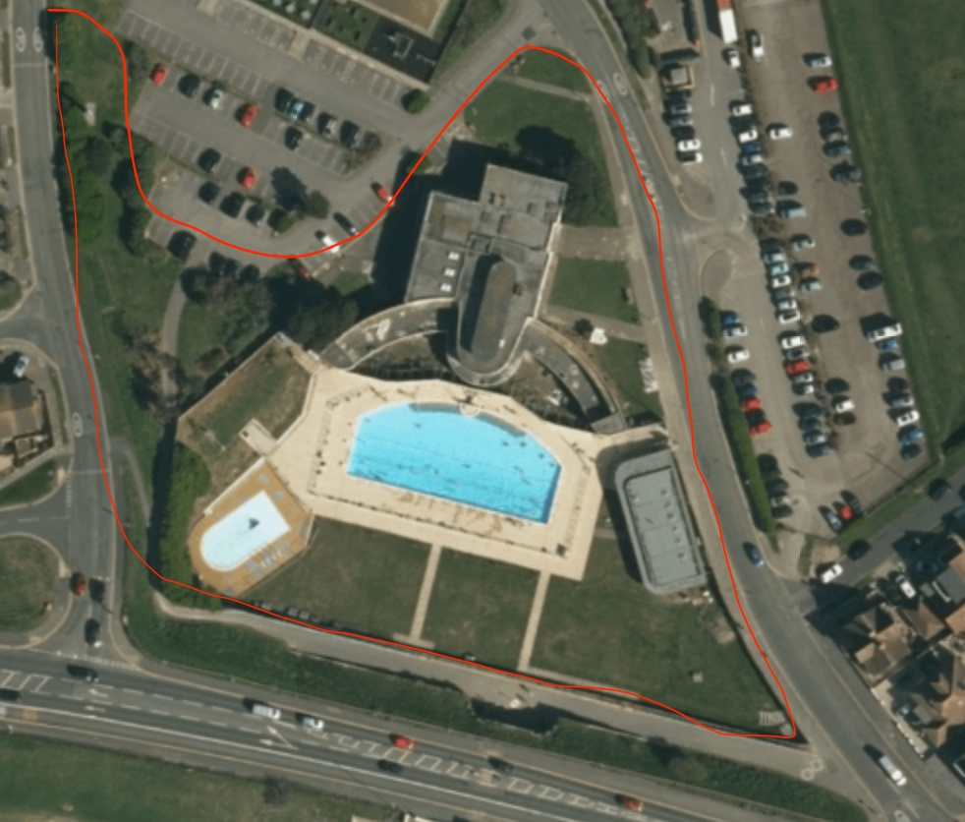

SITE 16 – The Cliff Top

Site Name and Address (location) | Grid Ref
The Cliff Top | 50°48’3”N  0°2’35”W
Site owner | BHCC
Have they been informed / discussed? | Yes
Description and purpose / current use: | narrow and exposed cliff-top well used by walkers and dogs
Statutory designations (eg SSSI) | None
Other designations (eg LNR) | None
Site allocations in Local Plan | No
Planning permission | Na
Access & proximity including how close to the community it serves (in meters)
List any public rights of way to or across the site: | Full
Which of the following criteria does it meet? | Fully / Partially / Not (if F or P provide details)
- Beauty | F
- Historic significance / heritage | F
- Recreational value | F.
- Tranquility | P Next to A259 so traffic can be heard and seen.
- Wildlife | F
Local in character – how would you describe for this statement?
narrow and exposed cliff-top well used by walkers and dogs

Area (in hectares) | 0.8
Photograph
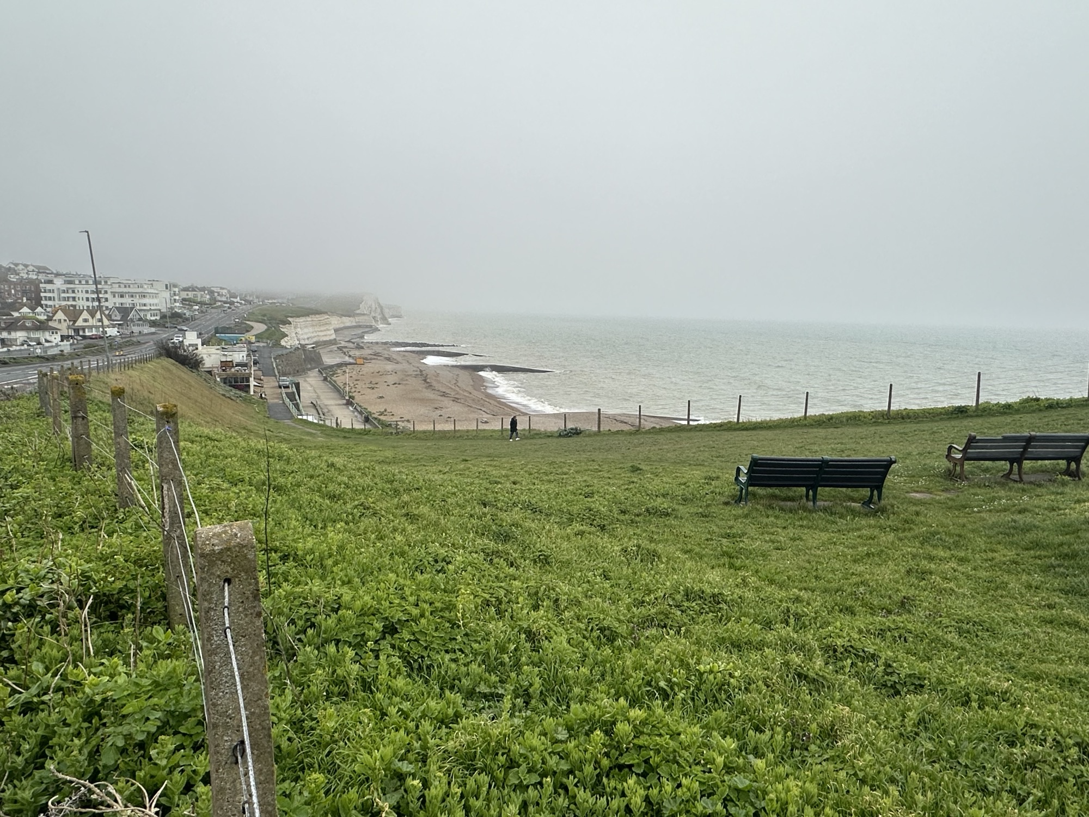
Aerial photo map or plan showing accurate boundary of site.
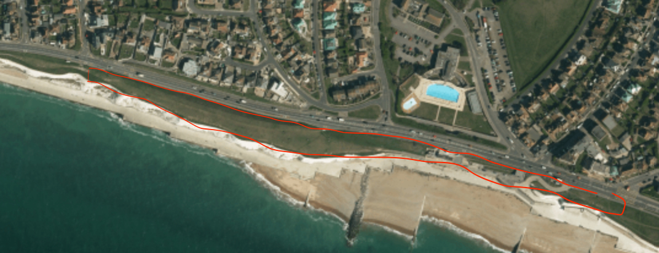

SITE 17 – Land south of Westfield Avenue North and east of Westfield Rise.

Added to plan on 16 May 2024 after same day assessment following identification of site during Reg 14 consultation day on 12 May.

Site Name and Address (location) | Grid Ref
Westfield Avenue North | 50°48’42”N  0°1’37”W
Site owner | Carr Family
Have they been informed / discussed? | Yes
Description and purpose / current use: | Chalk grassland currently grazed.  Bordered by trees and hedges.
Statutory designations (eg SSSI) | None
Other designations (eg LNR) | None
Site allocations in Local Plan | No
Planning permission | No. Included in BHCC CityPlan as part of development site for this area but proposed homes rejected due to incline of site.
Access & proximity including how close to the community it serves (in meters) | Parallel to existing and new homes 5m away.  Next to SDNP
List any public rights of way to or across the site: | None
Which of the following criteria does it meet? | Fully / Partially / Not (if F or P provide details)
- Beauty | F
- Historic significance / heritage | N
- Recreational value | N
- Tranquility | F
- Wildlife | F
Local in character – how would you describe for this statement?
Grazed strip with hedges. Grass chalkland. Abundant wildlife. Trees and hedges.
Area (in hectares) | 0.6
Photograph
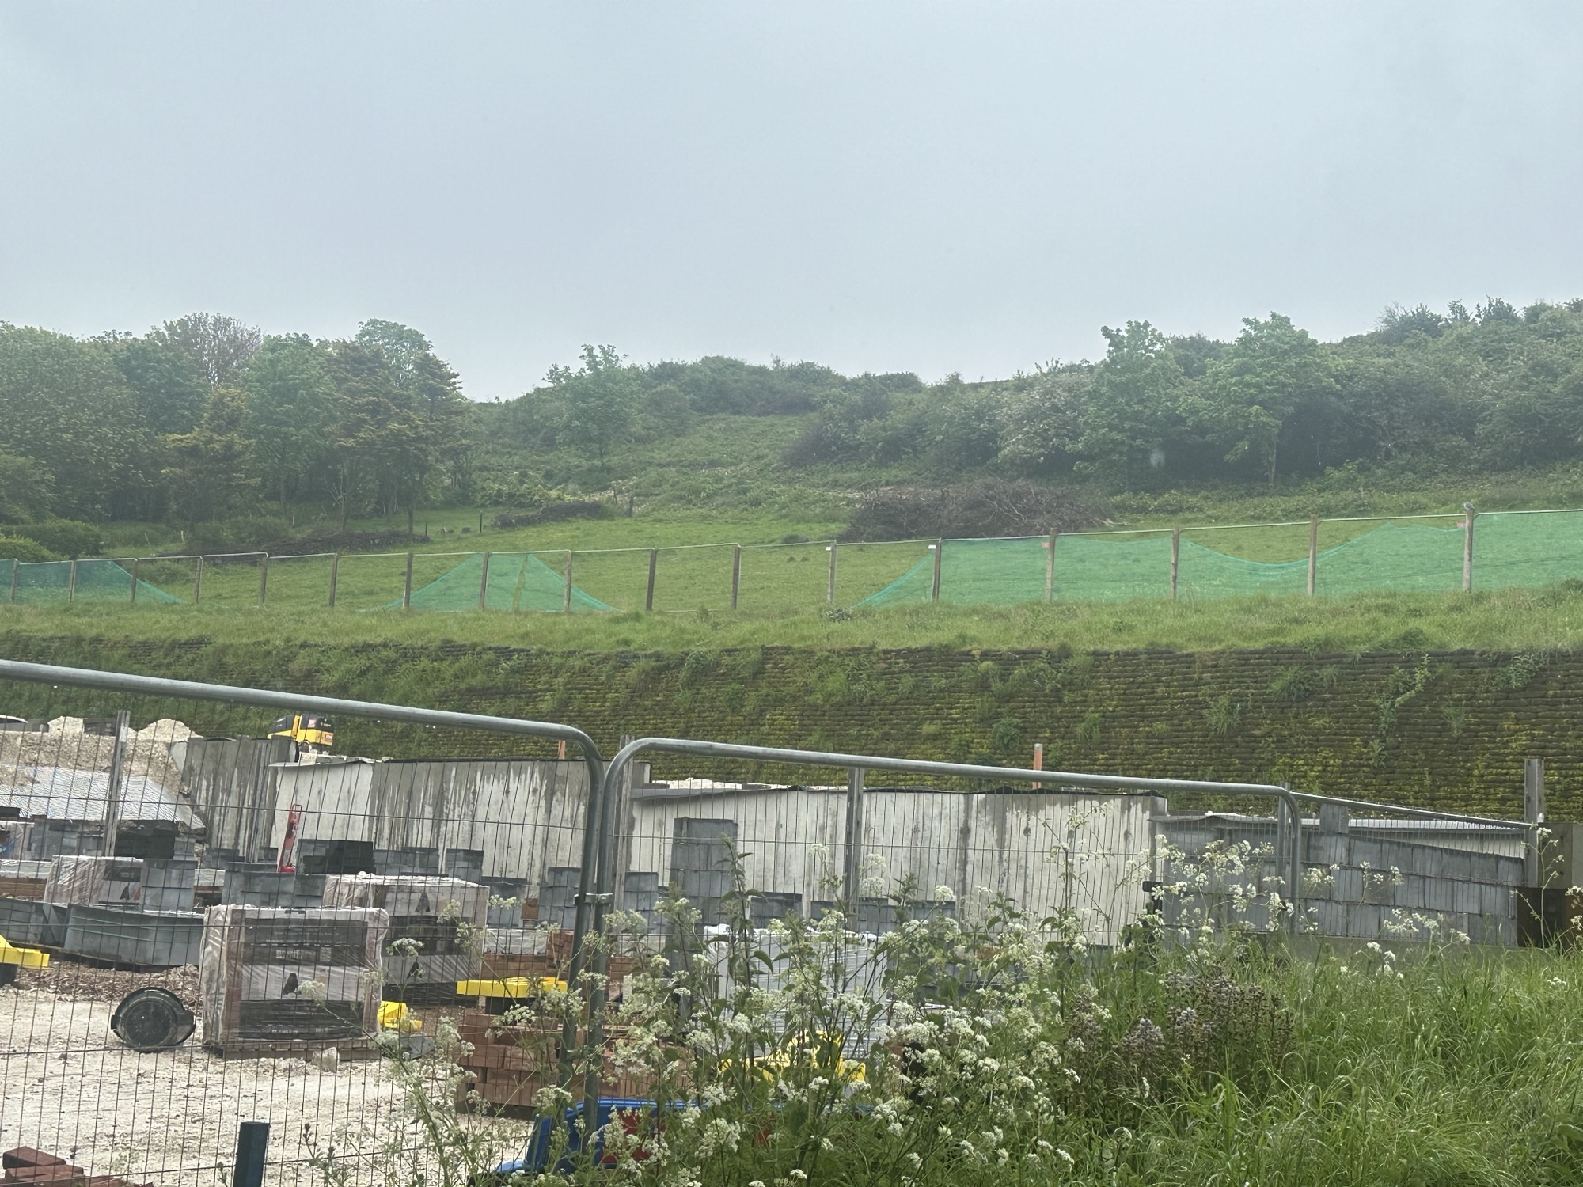
Aerial photo map or plan showing accurate boundary of site.
